

**SG2000**

**Preliminary Datasheet**

Version: 1.0

Release date: 2023-12-15

© 2023 SOPHGO

Revision History

|  |  |  |  |
| --- | --- | --- | --- |
| Revision | Date | Description | |
| 1.0 | 2023/12/15 | Preliminary release 1.0-alpha |
|  |  |  |
|  |  |  |
|  |  |  |
|  |  |  |
|  |  |  |
|  |  |  |
|  |  |  |
|  |  |  |
|  |  |  |

Contents

Revision History 2

1 Product Overview 8

1.1 Overview 8

1.2 Application Scenarios 8

1.2.1 SG2000 Intelligent IP Camera Solutions 8

1.2.2 SG2000 Intelligent Face Attendance Machine Solution 9

1.3 Architecture 10

1.3.1 Overview 10

1.3.2 Processor Core 10

1.3.3 TPU 11

1.3.4 Video Codec 11

1.3.5 Video Interface 11

1.3.6 ISP and Image Processing 12

1.3.7 CV Hardware Acceleration Engine 12

1.3.8 Audio Codec 13

1.3.9 Network Interface 13

1.3.10 Security System Module 13

1.3.11 Intelligent Secure Operating Environment 13

1.3.12 Peripheral Interface 14

1.3.13 External Memory Interface 14

1.3.14 SDK 15

1.3.15 Chip Physical Specifications 15

1.4 Boot and Upgrade Modes 15

1.4.1 Overview 15

1.4.2 Boot Mode and Corresponding Signal Latch Value Relationship 15

1.4.3 Image Burning Mode 16

1.4.4 Secure Boot 16

1.5 Address Space Mapping 17

2 Hardware Characteristics 21

2.1 Packaging and Pin Distribution 21

2.1.1 Package 21

2.1.2 Pin Distribution 22

2.2 Pin Information Description 22

2.3 Welding Process Suggestions 23

2.4 Moisture Sensitive Parameters 24

2.4.1 Moisture Barrier Packaging of SOPHGO Products 24

2.5 Electrical Performance Parameters 27

2.5.1 Power Consumption Parameters 27

2.5.2 Temperature and Thermal Resistance Parameters 27

2.5.3 Destructive Voltage 28

2.5.4 Power Up and Down Sequence 28

2.5.5 Power Supply DC/AC Electrical Parameters 32

2.5.6 1.8V I/O Electrical Parameters 34

2.5.7 18OD33 IO (VDDIO=1.8V) Electrical Parameters 34

2.5.8 18OD33 IO (VDDIO=3.0V) Electrical Parameters 35

2.5.9 Audio GPIO Electrical Parameters 37

2.5.10 ETH GPIO Electrical Parameters 37

2.5.11 MIPI Rx Electrical Parameters 37

2.5.12 Sub-LVDS Electrical Parameters 39

2.5.13 HiSPi Electrical Parameters 39

2.5.14 MIPI /LVDS Tx Electrical Parameters 40

2.5.15 SDIO Electrical Parameters 41

2.5.16 VI RAW/BT.601/BT.656/BT.1120 Electrical Parameters 41

2.5.17 VO BT.601/BT.656/BT.1120/8080 Electrical Parameters 41

2.5.18 AUDIO CODEC Electrical Parameters 42

2.6 Timing 43

2.6.1 SPI NOR Timing 43

2.6.2 SPI NAND Timing 44

2.6.3 VI Timing 46

2.6.4 VO Timing 46

2.6.5 AIAO (I2S/PCM) Timing 48

2.6.6 I2C Timing 50

2.6.7 SPI Timing 51

2.6.8 MIPI Rx Timing 52

2.6.9 Sub-LVDS Timing 53

2.6.10 HiSPi Timing 53

2.6.11 MIPI Tx Timing 55

2.6.12 SDIO/MMC Timing 57

**List of Figures**

Figure 1-1​​ Intelligent IP camera solution 9

Figure 1-2 Intelligent Face Attendance Machine Solution 9

Figure 2‑1 SG2000 package dimensions, top view 21

Figure 2‑2 SG2000 package dimensions, bottom view 22

Figure 2‑3 SG2000 pin distribution 22

Figure 2‑4 Lead-free reflow soldering process curve 23

Figure 2‑5 Vacuum drying packaging information 24

Figure 2‑6 Desiccant packs, humidity indicator card , chip and tray 25

Figure 2‑7 SPI NOR Timing Diagram 43

Figure 2‑8 SPI NAND Input Timing Diagram 44

Figure 2‑9 SPI NAND Output Timing Diagram 44

Figure 2‑10 VI Timing Diagram 46

Figure 2‑11 VO Timing Diagram 46

Figure 2‑12 BT.656 Timing Diagram 47

Figure 2‑13 BT.601 Timing Diagram 47

Figure 2‑14 BT.1120 Timing Diagram 47

Figure 2‑15 8080 Timing Diagram 48

Figure 2‑16 I2S & PCM Rx Timing Diagram 48

Figure 2‑17 I2S & PCM Tx Timing Diagram 49

Figure 2‑18 I2C Timing Diagram 50

Figure 2‑19 SPI Timing Diagram 51

Figure 2‑20 Timing Diagram of MIPI Rx Clock when 0.08Gbps ≤ Data Rate ≤ 1.5Gbps 52

Figure 2‑21 Sub-LVDSClock Data Timing Diagram 53

Figure 2‑22 HiSPi Clock Data Timing Diagram 54

Figure 2‑23 MIPI TX Data-to-Clock Timing Diagram 55

Figure 2‑24 TX EYE Diagram Specification 56

Figure 2‑25 Transmitter Eye Diagram Validation Setup 56

Figure 2‑26 SDIO/MMC single-edge (SDR) data input/output timing diagram 57

Figure 2‑27 SDIO/MMC double edge DDR50 mode data input/output timing diagram 58

Figure 2‑28 SDIO/MMC HS200 and SDR104 mode data command input/output timing diagram 59

**List of Tables**

Table 2‑1 Lead-Free Reflow Soldering Cap Parameters 23

Table 2‑2 Humidity Classification And Floor Life 25

Table 2‑3 Baking Temperature and Timetable 26

Table 2‑4 SG2000 Thermal Resistance Parameters 27

Table 2‑5 Temperature-Related Parameters 27

Table 2‑6 Destructive Voltage Parameters 28

Table 2‑7 Power Supply Electrical Parameters (Recommended Operating Conditions) 32

Table 2‑8 1.8V IO Electrical Parameters 34

Table 2‑9 18OD33 IO (VDDIO=1.8V) Electrical Parameters 34

Table 2‑10 18OD33 IO (VDDIO=3.0V) Electrical Parameters 35

Table 2‑11 Audio GPIO Electrical Parameters 37

Table 2‑12 ETH GPIO Electrical Parameters 37

Table 2‑13 MIPI D-PHY High Speed (MISH) Differential DC Electrical Parameters 38

Table 2‑14 MIPI D-PHY High Speed (MIHS) Differential AC Electrical Parameters 38

Table 2‑15 MIPI D-PHY Low Power (MILP) Differential DC Electrical Parameters 38

Table 2‑16 MIPI D-PHY Low Power (MILP) Differential AC Electrical Parameters 39

Table 2‑17 Sub-LVDS (SL) Differential DC Electrical Parameters 39

Table 2‑18 Sub-LVDS(SL) Differential AC Electrical Parameters 39

Table 2‑19 HiSPi Differential DC Electrical Parameters 39

Table 2‑20 HiSPi Differential AC Electrical Parameters 40

Table 2‑21 MIPI HS Transmitter DC Specifications 40

Table 2‑22 MIPI HS Transmitter AC Specifications 40

Table 2‑23 MIPI LP Transmitter DC Specifications 40

Table 2‑24 MIPI LP Transmitter AC Specifications 41

Table 2‑25 LVDS Transmitter DC/AC Specifications 41

Table 2‑26 Audio CODEC Overall Indicator Table 42

Table 2‑27 Audio DAC Electrical Parameters 42

Table 2‑28 Audio ADC Electrical Parameters 42

Table 2‑29 SPI_NOR Timing Parameter Table 43

Table 2‑30 SPI NAND Input Timing 44

Table 2‑31 SPI NAND Output Timing 44

Table 2‑32 VI Timing Parameter Table 46

Table 2‑33 VO Timing Parameter Table 47

Table 2‑34 I2S/PCM Timing Parameter Table 49

Table 2‑35 I2C Timing Parameter Table 50

Table 2‑36 SPI Timing Parameter Table 51

Table 2‑37 Timing Parameter of MIPI Rx at 0.08Gbps ≤ Data Rate ≤ 1.5Gbps 52

Table 2‑38 Sub-LVDS Timing Parameter Table 53

Table 2‑39 HiSPi Timing Parameters Table 54

Table 2‑40 Data-Clock Timing Specifications for ≥ 0.08Gbps and ≤ 1 Gbps 55

Table 2‑41 Data-Clock Timing Specifications for > 1Gbps and ≤ 1.5 Gbps 55

Table 2‑42 Data-Clock Timing Specifications for > 1.5Gbps and ≤ 2.5 Gbps 55

Table 2‑43 Transmitter Eye Diagram Specification 56

Table 2‑44 SDIO/MMC Single Edge DS (Default Speed) Mode Timing Parameter Table 57

Table 2‑45 SDIO/MMC Single Edge HS (High Speed) Mode Timing Parameter Table 58

Table 2‑46 SDIO/MMC Double Edge DDR50 Mode Timing Parameter Table 59

Table 2‑47 SDIO/MMC HS200 and SDR104 Mode Output Parameters Table 59

Table 2‑48 SDIO/MMC HS200 and SDR104 Mode Input Timing Parameter Table 60

# Product Overview

## Overview

SG2000 is a high-performance, low-power chip for edge intelligent surveillance IP cameras, local face recognition time and attendance machines, home intelligence and many other product areas, integrated with H.264 video compression codec, H.265 video compression encoder and ISP; support for HDR Wide Dynamic, 3D noise reduction, demisting, lens aberration correction and other image enhancement and correction algorithms, to provide professional-grade video image quality for the customer.

The chip also integrates a self-developed TPU, which can provide 0.5TOPS of arithmetic power under 8-bit integer operation. The specially designed TPU scheduling engine efficiently provides extremely high bandwidth data flow to all tensor processor cores. Powerful deep learning model compilers and software SDK development kits are also available for users. Mainstream deep learning frameworks like Caffe and Tensorflow can be easily ported to its platform.

In addition, it also provides secure boot, secure update, secure encryption, etc., providing users with a series of security solutions from development, mass production, and product application.

An 8-bit MCU subsystem is integrated in the chip, which can replace the external MCU to save BOM cost and power consumption.

## Application Scenarios

### SG2000 Intelligent IP Camera Solutions

The typical application scenarios for intelligent IP camera solutions are shown in Figure 1-1.

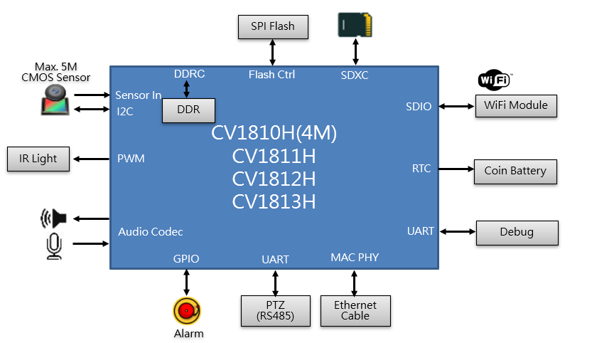

SG2000

Figure 1-1​​ intelligent IP camera solution

### SG2000 Intelligent Face Attendance Machine Solution

The typical application scenario for Intelligent Face Attendance Machine Solution is shown in Figure 1-2.

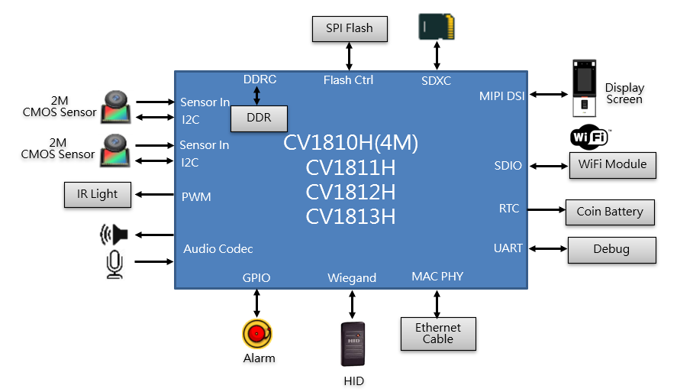

SG2000

Figure 1-2 Intelligent Face Attendance Machine Solution

## Architecture

### Overview

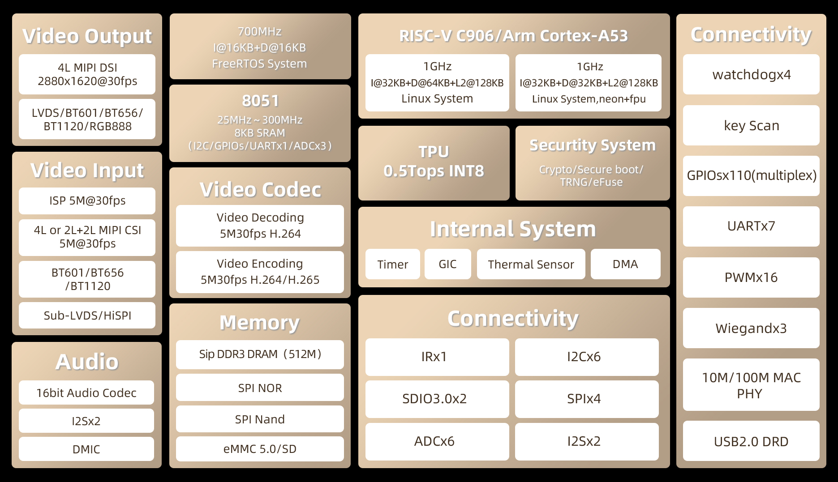

Figure 1-3 SG200 Architecture Diagram

### Processor Core

* Main processor RISCV C906 @ 1.0Ghz
  + 32KB I-cache, 64KB D-Cache
  + Integrated Vector and floating-point unit (FPU)
* Main processor ARM Cortex-A53 @ 1.0Ghz
  + 32KB I-cache, 32KB D-Cache
  + 128KB L2 cache
  + Support Neon and floating-point unit (FPU)
* Coprocessor RISCV C906 @ 700Mhz
  + Integrated floating-point unit (FPU)

### TPU

* Built-in SOPHGO TPU, computing power reaches ~0.5TOPS INT8
* Supports mainstream neural network architectures: Caffe, Pytorch, TensorFlow (Lite), ONNX and MXNet
* It can realize pedestrian detection, face detection, face recognition, face anti-spoofing and other video structured applications.

### Video Codec

* H.264 Baseline/Main/High profile
* H.265 Main profile
* H.264/H.265 both support I frames and P frames
* MJPEG/JPEG baseline
* H.264 codec maximum resolution: 2880×1620 (5M)
* H.265 encoding maximum resolution: 2880×1620 (5M)
* H.264 codec performance
  + 2880×1620@30fps+720×576@30fps
  + 2304×1296@30fps encoding + 1920×1080@30fps decoding
* H.265 encoding performance
  + 2880×1620@30fps+720×576@30fps
* JPEG maximum codec performance
  + 2880×1620@30fps
* Support multiple bitrate control modes, including CBR/VBR/FIX.
* Support Region of interest (ROI) encoding

### Video Interface

* Input
  + Support three simultaneous video inputs (mipi 2L+2L+DVP)
  + Support MIPI, Sub-LVDS, HiSPI and other serial interfaces
  + Support 8/10/12 bit RGB Bayer video input
  + Support BT.601, BT.656, BT.1120 video input
  + Support AHD multi-channel mixed BT format
  + Support SONY, OnSemi, OmniVision and other high-definition CMOS sensor
  + Provide a programmable frequency output for the sensor as a reference clock.
  + Supports a maximum width of 2880 and a maximum resolution of 5M (2688×1944, 2880×1620)
* Output
  + Supports a variety of serial and parallel screen display specifications.
  + Support MIPI, LVDS and other serial interfaces
  + Support BT.601, BT.656, BT.1120, RGB565/666/888, 8080 output interface
  + Support SPI output interface

### ISP and Image Processing

* Support image or video rotation by 90, 180, or 270-degrees
* Support horizontal (Flip) or vertical (Mirror) flipping of image or video
* Support overlaying two layers of OSD (On-Screen Display) on the video
* Support video scaling down to 1/32 or up to 32 times
* Support 3A algorithm: automatic exposure (AE), automatic white balance (AWB), and automatic autofocus (AF)
* Support fixed-mode noise reduction and bad pixel correction
* Support correction of lens shading, distortion, and purple fringing
* Support direction-adaptive demosaic algorithm that selects the best demosaic algorithm based on the image orientation
* Support Gamma correction, dynamic contrast enhancement, and color management algorithms
* Support regional adaptive defogging
* Support Bayer denoising, 3D denoising, detail enhancement, and sharpening enhancement
* Support Local Tone mapping
* Support sensor with wide dynamic range and 2-frame wide dynamic range
* Support two-axis digital image stabilization
* Support lens distortion correction
* Provide PC-side ISP tuning tools

### CV Hardware Acceleration Engine

* The mixed mode of software and hardware supports some OpenCV libraries.
* Software and hardware mixed mode support part IVE libraries

### Audio Codec

* Integrated Audio CODEC, supports 16-bit audio source / voice input and output
* Integrated two-channel microphone input
* Integrated two-channel output. (An external amplifier is required to drive the speakers)
* Connecting to external audio CODEC through I2S/PCM/TDM interface. The built-in audio PLL supports MCLK output
* Software audio codec protocols (G.711, G.726, ADPCM)
* Software supports audio 3A (AEC, ANR, AGC) functions

### Network Interface

* The Ethernet module provides an Ethernet MAC to receive and send network data.
* The Ethernet MAC, combined with the built-in 10/100Mbps Fast Ethernet Transceiver, can operate in 10/100Mbps full-duplex or half-duplex mode. It can also plug in an external PHY through the RMII interface.

### Security System Module

* Hardware implements AES/DES/SM4 multiple encryption and decryption algorithms
* Hardware implementation of HASH (SHA1/SHA256) hash algorithm
* Hardware implementation of random number generator
* Internally integrated 2Kbit eFuse logical space

### Intelligent Secure Operating Environment

* Support the establishment of a trust chain: provide the basis for a secure environment, which is the foundation of a trusted environment, such as hardware security settings, root of trust, etc.
* Support secure boot and provide security hardware and software protection functions
* Support data encryption security: data encryption program, computing core encryption
* Support software and firmware signature verification process: confirms software trustworthiness and integrity, including boot and loading signature verification program
* Support secure storage and transmission: protects external data storage and exchange
* Support secure updates

### Peripheral Interface

* Integrated POR, Power sequence, and RTC clock
* 6 single-ended ADCs (3 no die domain)
* 6 I2C (1 no die domain)
* 4 SPI​
* 7 groups of UART (2 no die domain)
* 4 groups (16 channels) PWM
* 2 SDIO interfaces  
  One supports 3V/1.8V to connect to SD 3.0 Card (support maximum capacity SDXC 2TB, supported speed is UHS-I)   
  One supports 1.8V to connect to other SDIO 3.0 devices. (supported speed is UHS-I)
* 110 GPIO interface (25 no die domain)
* Integrate keyscan and Wiegand
* Integrated MAC PHY supports 10/100Mbps full-duplex or half-duplex mode. External PHY can also be plugged in through RMII
* One USB Host/device interface
* Two sets of I2S

### External Memory Interface

* Built-in DRAM
  + DDR3 16bit×1, maximum speed up to 1866Mbps, capacity 4Gbit (512MB)
* SPI NOR flash interface (1.8V / 3.0V)
  + Supports 1, 2, and 4- wire modes.
  + Maximum support is 256MByte
* SPI Nand flash interface (1.8V / 3.0V)
  + Supports 1KB/2KB/4KB page (corresponding maximum capacity 16GB/32GB/64GB)
  + ECC module built into the device itself
* eMMC 4.5 interface (1.8V/3.0V)
  + 4-bit interface
  + Support HS200
  + Maximum supported capacity 2TB

### SDK

* Linux-5.10-based SDK

### Chip Physical Specifications

* Power consumption
  + 1080P + Video encode + AI: ~500mW
  + Other scenarios: TBD
* Operating Voltage
  + Core voltage: 0.9V
  + IO voltage: 1.8V and 3.0V
  + DDR voltage: 1.35V
* Package
  + Using LFBGA package, the package size is 10mm×10mm×1.3mm. The pin pitch is 0.65mm. The total number of pins is 205.

## Boot and Upgrade Modes

### Overview

The chip is booted by the built-in ROM (BOOTROM) . When the chip is reset, it will detect whether there is a weak pull-up or weak pull-down on the two pins (EMMC_DAT3, EMMC_DAT0) to determine the type of memory device currently.

For chips with secure boot, software execution or upgrades will be verified during startup and chip upgrades to ensure that the software being executed or upgraded is secure.

### Boot Mode and Corresponding Signal Latch Value Relationship

* Support booting by SPI Nor Flash (EMMC_DAT3 pull down, EMMC_DAT0 pull up)
* Support booting from SPI Nand Flash (EMMC_DAT3 pull down, EMMC_DAT0 pull down)
* Support booting from eMMC (EMMC_DAT3 pull up, EMMC_DAT0 pull up)

### Image Burning Mode

* Support image burning through SD card
* Support image burning through USB device mode
* If there is an image in flash, the software supports software upgrade via the network

### Secure Boot

* Support secure boot and upgrade
* AES/DES/SM4 hardware encryption and decryption
* SHA/TRNG/Secure eFuse security hardware

## Address Space Mapping

|  |  |  |  |
| --- | --- | --- | --- |
| **Starting Address** [31:0] | **End Address** [31:0] | **Space Function** | **Space Size** (Byte) |
| 0x01000000 | 0x017FFFFF | reserve | 8M |
| 0x01800000 | 0x018FFFFF | reserve |  |
| 0x01900000 | 0x01900FFF | ap_mailbox | 4K |
| 0x01901000 | 0x01901FFF | ap_system_ctrl | 4K |
| 0x01902000 | 0x019EFFFF | reserve |  |
| 0x01F00000 | 0x01F0FFFF | reserve | 64K |
| 0x01F10000 | 0x01FFFFFF | reserve |  |
| 0x02000000 | 0x02FFFFFF | reserve | 64K |
| 0x03000000 | 0x03000FFF | TOP_MISC control register | 4K |
| 0x03001000 | 0x03001FFF | PINMUX control register | 4K |
| 0x03002000 | 0x03002FFF | CLKGEN/PLL control register | 4K |
| 0x03003000 | 0x03003FFF | RSTGEN control register | 4K |
| 0x03004000 | 0x03005FFF | reserve |  |
| 0x03006000 | 0x03006FFF | reserve | 4K |
| 0x03007000 | 0x03008FFF | reserve |  |
| 0x03009000 | 0x03009FFF | reserve | 4K |
| 0x0300A000 | 0x0300AFFF | reserve | 4K |
| 0x0300B000 | 0x0300FFFF | reserve |  |
| 0x03010000 | 0x03010FFF | WATCH DOG0 control register | 4K |
| 0x03011000 | 0x03011FFF | WATCH DOG1 control register | 4K |
| 0x03012000 | 0x03012FFF | WATCH DOG2 control register | 4K |
| 0x03020000 | 0x03020FFF | GPIO0 control register | 4K |
| 0x03021000 | 0x03021FFF | GPIO1 control register | 4K |
| 0x03022000 | 0x03022FFF | GPIO2 control register | 4K |
| 0x03023000 | 0x03023FFF | GPIO3 control register | 4K |
| 0x03024000 | 0x0302FFFF | reserve |  |
| 0x03030000 | 0x03030FFF | WGN0 control register | 4K |
| 0x03031000 | 0x03031FFF | WGN1 control register | 4K |
| 0x03032000 | 0x03032FFF | WGN2 control register | 4K |
| 0x03033000 | 0x0303FFFF | reserve |  |
| 0x03040000 | 0x0304FFFF | KEYSCAN control register | 64K |
| 0x03050000 | 0x0305FFFF | EFUSE control register | 64K |
| 0x03060000 | 0x03060FFF | PWM0 control register | 4K |
| 0x03061000 | 0x03061FFF | PWM1 control register | 4K |
| 0x03062000 | 0x03062FFF | PWM2 control register | 4K |
| 0x03063000 | 0x03063FFF | PWM3 control register | 4K |
| 0x03064000 | 0x0309FFFF | reserve |  |
| 0x030A0000 | 0x030AFFFF | TIMER control register | 64K |
| 0x030C0000 | 0x030CFFFF | reserve |  |
| 0x030D0000 | 0x030D0FFF | reserve | 4K |
| 0x030D1000 | 0x030D1FFF | reserve | 4K |
| 0x030D2000 | 0x030D2FFF | reserve | 4K |
| 0x030D3000 | 0x030DFFFF | reserve |  |
| 0x030E0000 | 0x030EFFFF | TEMPSEN control register | 64K |
| 0x030F0000 | 0x030FFFFF | SARADC control register | 64K |
| 0x04000000 | 0x0400FFFF | I2C0 control register | 64K |
| 0x04010000 | 0x0401FFFF | I2C1 control register | 64K |
| 0x04020000 | 0x0402FFFF | I2C2 control register | 64K |
| 0x04030000 | 0x0403FFFF | I2C3 control register | 64K |
| 0x04040000 | 0x0404FFFF | I2C4 control register | 64K |
| 0x04050000 | 0x0405FFFF | reserve |  |
| 0x04060000 | 0x0406FFFF | SPI_NAND control register | 64K |
| 0x04070000 | 0x0407FFFF | ETH0 control register |  |
| 0x04080000 | 0x040FFFFF | reserve |  |
| 0x04100000 | 0x04107FFF | I2S0 control register | 64K |
| 0x04108000 | 0x0410FFFF | I2S Global Control Register | 64K |
| 0x04110000 | 0x0411FFFF | I2S1 control register | 64K |
| 0x04120000 | 0x0412FFFF | I2S2 control register | 64K |
| 0x04130000 | 0x0413FFFF | I2S3 control register | 64K |
| 0x04140000 | 0x0414FFFF | UART0 control register | 64K |
| 0x04150000 | 0x0415FFFF | UART1 control register | 64K |
| 0x04160000 | 0x0416FFFF | UART2 control register | 64K |
| 0x04170000 | 0x0417FFFF | UART3 control register | 64K |
| 0x04180000 | 0x0418FFFF | SPI0 control register | 64K |
| 0x04190000 | 0x0419FFFF | SPI1 control register | 64K |
| 0x041A0000 | 0x041AFFFF | SPI2 control register | 64K |
| 0x041B0000 | 0x041BFFFF | SPI3 control register | 64K |
| 0x041C0000 | 0x041CFFFF | UART4 control register | 64K |
| 0x041D0000 | 0x041DFFFF | AUDSRC control register | 64K |
| 0x041E0000 | 0x042FFFFF | reserve |  |
| 0x04300000 | 0x0430FFFF | eMMC control register | 64K |
| 0x04310000 | 0x0431FFFF | SD0 control register | 64K |
| 0x04320000 | 0x0432FFFF | SD1 control register |  |
| 0x04330000 | 0x0433FFFF | DMA control register | 64K |
| 0x04340000 | 0x0434FFFF | USB control register | 64K |
| 0x04350000 | 0x043FFFFF | reserve |  |
| 0x04400000 | 0x0441FFFF | ROM memory space | 128K |
| 0x04420000 | 0x04FFFFFF | reserve |  |
| 0x05000000 | 0x05000FFF | reserve | 4KB |
| 0x05020000 | 0x05020FFF | RTCSYS_Timer control register | 4KB |
| 0x05021000 | 0x05021FFF | RTCSYS_GPIO control register | 4KB |
| 0x05022000 | 0x05022FFF | RTCSYS_UART control register | 4KB |
| 0x05023000 | 0x05023FFF | RTCSYS_INTR control register | 4KB |
| 0x05024000 | 0x05024FFF | RTCSYS_MBOX control register | 4KB |
| 0x05025000 | 0x05025FFF | RTCSYS_CTRL control register | 4KB |
| 0x05026000 | 0x05026FFF | RTCSYS_CORE | 4KB |
| 0x05027000 | 0x05027FFF | RTCSYS_IO control register | 4KB |
| 0x05028000 | 0x05028FFF | RTCSYS_OSC control register | 4KB |
| 0x05029000 | 0x05029FFF | reserve | 4KB |
| 0x0502A000 | 0x0502AFFF | RTCSYS_32kless control register | 4KB |
| 0x0502B000 | 0x0502BFFF | RTCSYS_I2C control register | 4KB |
| 0x0502C000 | 0x0502CFFF | RTCSYS_SAR control register | 4KB |
| 0x0502D000 | 0x0502DFFF | RTCSYS_WDT control register | 4KB |
| 0x0502E000 | 0x0502EFFF | RTCSYS_IRRX control register | 4KB |
| 0x05200000 | 0x053FFFFF | RTCSYS_SRAM | 8KB |
| 0x05400000 | 0x057FFFFF | RTCSYS_SPINOR | 4MB |
| 0x08000000 | 0x08001FFF | reserve | 8K |
| 0x08004000 | 0x08005FFF | DDR Controller Control Register | 8K |
| 0x08006000 | 0x08007FFF | reserve | 8K |
| 0x08008000 | 0x08009FFF | DDR AXI Monitor Control Register | 8K |
| 0x0800A000 | 0x0800BFFF | DDR Global Control Register | 8K |
| 0x08010000 | 0x08011FFF | reserve | 8K |
| 0x08012000 | 0x08013FFF | reserve | 8K |
| 0x08014000 | 0x09FFFFFF | reserve |  |
| 0x0A000000 | 0x0A07FFFF | ISP control register | 512K |
| 0x0A080000 | 0x0A0803FF | sc_top control register | 1K |
| 0x0A080400 | 0x0A080BFF | reserve | 2K |
| 0x0A080C00 | 0x0A080CFF | osd enc control register | 256B |
| 0x0A080D00 | 0x0A080FFF | reserve | 768B |
| 0x0A081000 | 0x0A081FFF | reserve | 4K |
| 0x0A082000 | 0x0A082FFF | img_v control register | 4K |
| 0x0A083000 | 0x0A083FFF | img_d control register | 4K |
| 0x0A084000 | 0x0A084FFF | sc_d control register | 4K |
| 0x0A085000 | 0x0A085FFF | sc_v1 control register | 4K |
| 0x0A086000 | 0x0A086FFF | sc_v2 control register | 4K |
| 0x0A087000 | 0x0A087FFF | sc_v3 control register | 4K |
| 0x0A088000 | 0x0A088FFF | DISP control register | 4K |
| 0x0A089000 | 0x0A089FFF | reserve | 4K |
| 0x0A08A000 | 0x0A08AFFF | dsi_mac control register | 4K |
| 0x0A08B000 | 0x0A08BFFF | cmdq control register | 4K |
| 0x0A08C000 | 0x0A08CFFF | reserve | 4K |
| 0x0A08D000 | 0x0A08DFFF | reserve | 4K |
| 0x0A08E000 | 0x0A09FFFF | reserve | 72K |
| 0x0A0A0000 | 0x0A0AFFFF | IVE control register | 64K |
| 0x0A0A0000 | 0x0A0BFFFF | reserve | 64K |
| 0x0A0C0000 | 0x0A0C1FFF | ldc control register | 8K |
| 0x0A0C2000 | 0x0A0C3FFF | VI0/MIPI_RX0 control register | 8K |
| 0x0A0C4000 | 0x0A0C5FFF | VI1/MIPI_RX1 control register | 8K |
| 0x0A0C6000 | 0x0A0C7FFF | VI2/MIPI_RX2 control register | 8K |
| 0x0A0C8000 | 0x0A0C9FFF | VIPSYS control register | 8K |
| 0x0A0CA000 | 0x0A0CFFFF | reserve | 24K |
| 0x0A0D0000 | 0x0A0D0FFF | CSI_PHY control register | 4K |
| 0x0A0D1000 | 0x0A0D1FFF | DSI_PHY control register | 4K |
| 0x0A0D2000 | 0x0AFFFFFF | reserve |  |
| 0x0B000000 | 0x0B00FFFF | JPEG codec control register | 64K |
| 0x0B010000 | 0x0B01FFFF | H.264 codec control register | 64K |
| 0x0B020000 | 0x0B02FFFF | H.265 codec control register | 64K |
| 0x0B030000 | 0x0BFFFFFF | reserve |  |
| 0x0C000000 | 0x0FFFFFFFF | reserve |  |
| 0x10000000 | 0x1FFFFFFFF | SPI_NOR memory space | 256M |
| 0x30000000 | 0x7FFFFFFFF | reserve |  |
| 0x80000000 | 0xFFFFFFFF | DDR memory space | 2G |

* Performing read/write operations on the reserved address space may result in unpredictable results.

# Hardware Characteristics

## Packaging and Pin Distribution

### Package

SG2000 uses LFBGA package with a package size of 10mm×10mm×1.3mm. The pin pitch is 0.65mm and there are a total of 205 pins. For detailed package dimensions, please refer to the figure below.

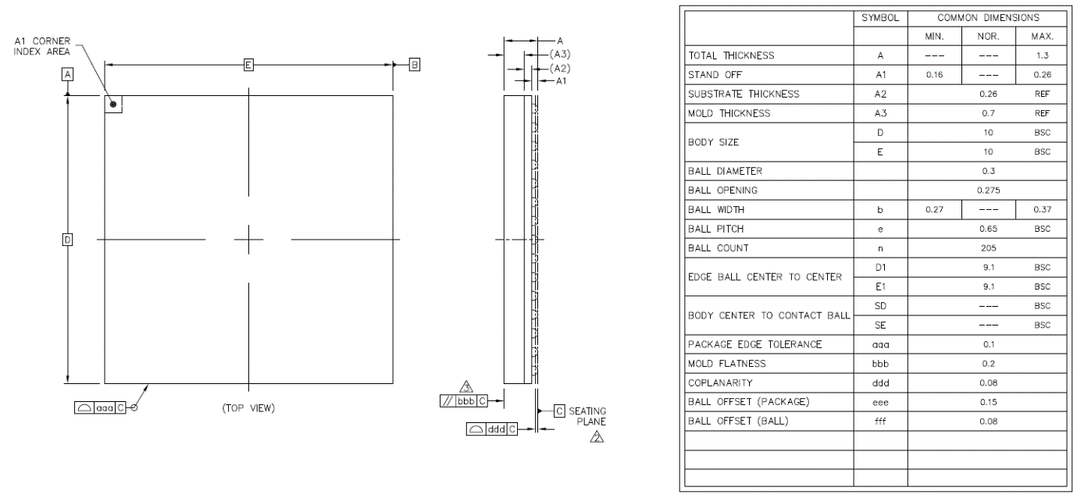

Figure 2‑1 SG2000 package dimensions, top view

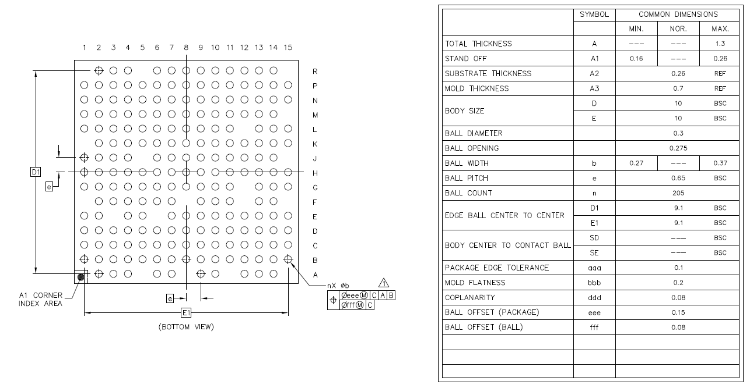

Figure 2‑2 SG2000 package dimensions, bottom view

### Pin Distribution

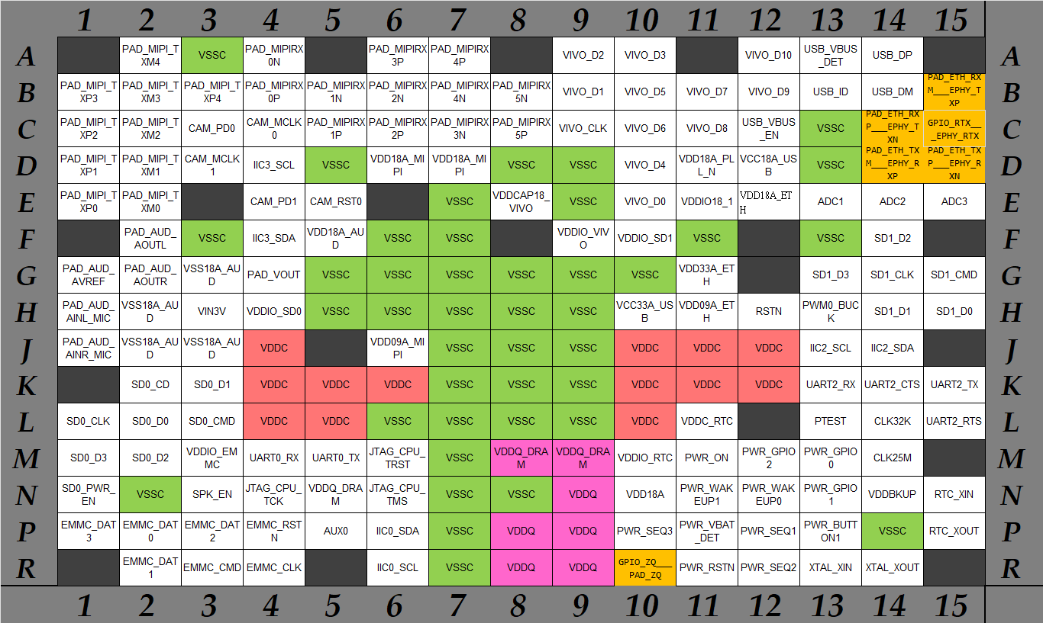

Figure 2‑3 SG2000 pin distribution

## Pin Information Description

Please refer to SG2000_PINOUT_CN.xlsx

## Welding Process Suggestions

Please refer to Figure 2‑4 for the lead-free reflow soldering process curve.

SG2000 please refer to Sn/Ag/Cu

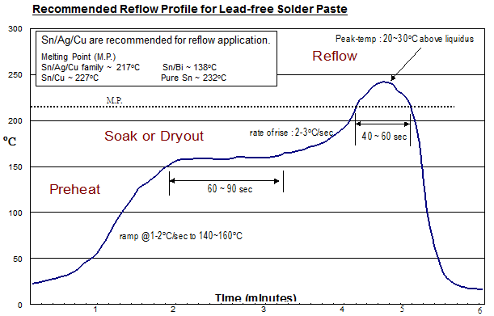

Figure 2‑4 Lead-free reflow soldering process curve

Please refer to Table 2‑1 for the parameters of lead-free reflow soldering process.

* The following parameters are only recommended values for reference, and the client needs to make corresponding adjustments according to actual production conditions.

Table 2‑1 Lead-free reflow soldering cap parameters

|  |  |  |  |  |
| --- | --- | --- | --- | --- |
| Area | Time | Heating Rate | Peak Temperature | Cooling Rate |
| Preheating zone (40~150oC) | 60~120sec | 1~2oC/sec |  |  |
| Soak zone (150~200 oC) | 60~90sec | < 1oC/sec |  |  |
| Reflow zone  (> melting point 20~30 oC) | 40~60sec | 2~3oC/sec | Sn/Ag/Cu 237~247oC  Sn/Cu 247~257oC  Pure Sn 252~262oC |  |
| Cooling zone  (Tmax ~ Tamb) |  |  |  | 1~4oC/sec |

Due to environmental protection considerations, the parameters for leaded reflow soldering are not provided currently.

## Moisture Sensitive Parameters

### Moisture Barrier Packaging of SOPHGO Products

This section establishes the principles for the storage and use of chips (moisture sensitive products) during welding. The relevant terms are as follows:

* Floor life: refers to the maximum time allowed to stay between unpacking the moisture-proof packaging and reflowing in an environment < 30°C/60% RH.
* Shelf life: refers to the normal storage time after the moisture barrier packaging has been sealed.

#### Packaging Information

The moisture-proof vacuum bag contains (1) chip and tray (2) desiccant packs, and (3) humidity indicator card (HIC)

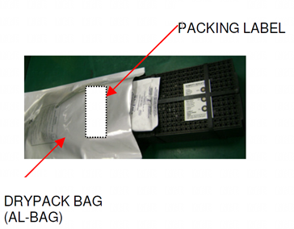

Figure 2‑5 Vacuum drying packaging information

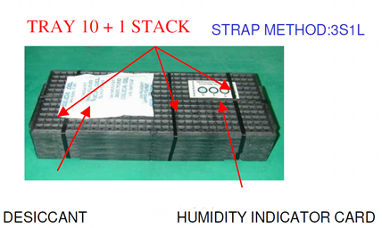

Figure 2‑6 Desiccant packs, humidity indicator card , chip and tray

#### Moisture Sensitive Product Incoming Inspection

After opening the vacuum moisture-proof bag before SMT, inspect the humidity card. There are many different styles of humidity cards, but if it shows that it has been exposed to moisture, it must be baked before SMT use. The relevant time and temperature parameters for baking are shown in Table 2‑3.

If re-packaging after opening, and it has not been exposed for more than 2 hours in an environment of < 30oC /60% RH, it can be vacuum dried and packaged by only replacing the drying bag. If it exceeds 2 hours, it is recommended to re-bake, replace the drying bag, and then reseal the package.

#### Storage and Use (Refer to JEDEC J-STD-033)

* Shelf life  
  The sealed vacuum moisture-proof bag can be stored for at least 12 months in an environment of 40°C/90% RH.
* Floor life  
  Before SMT, if the humidity card indicates that the components have not been exposed to moisture after opening in an environment of 30°C/60% RH, it can be used directly without baking. The time for Level 3 (the floor life classification of this chip is Level 3) is shown in Table 2‑2.

Table 2‑2 Humidity classification and floor life

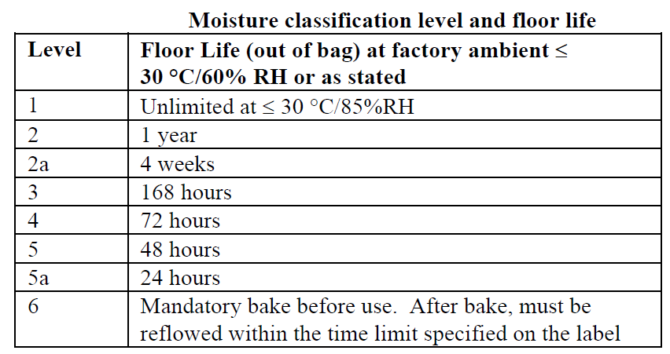

#### Rebaking

If found to have been exposed to moisture after opening, before SMT or before being resealed in vacuum packaging, they should be baked first. Baking temperature and time can be referred to in Table 2‑3.

After baking, shelf life can be recalculated after being sealed in moisture-proof packaging.

If not sealed in moisture-proof packaging after baking, the storage time should refer to the floor life.

Table 2‑3 Baking temperature and timetable

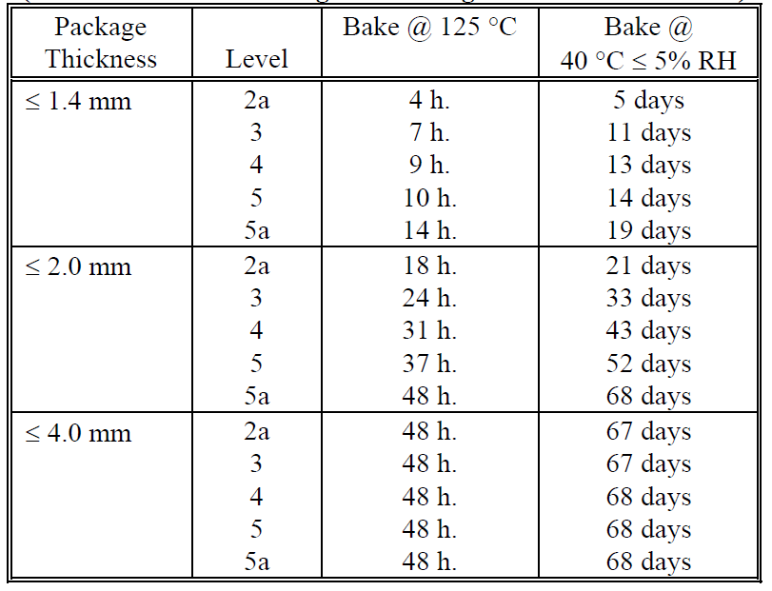

## Electrical Performance Parameters

### Power Consumption Parameters

Typical scenario: 1080P + Video Encode + AI ~500mW

Other scenarios: TBD

### Temperature and Thermal Resistance Parameters

Thermal resistance values ThetaJA, JB, JC of the chip. The results of the actual test conducted on the JEDEC 2s2p PCB are shown in Table 2‑4.

Table 2‑4 SG2000 thermal resistance parameters

|  |  |  |  |  |  |  |  |
| --- | --- | --- | --- | --- | --- | --- | --- |
| PCB Condition | Package Size(mm) | Theta JA (C/W) | | | Psi Jt  (C/W) | Theta JC  (C/W) | Theta JB (C/W) |
| 0 m/s | 1 m/s | 2 m/s |
| JEDEC 2s2p PCB | 10×10 | 31.6 | 28.2 | 27.2 | 0.35 | 6.20 | 15.80 |

Temperature-related parameters of the chip are shown in Table 2‑5.

Table 2‑5 Temperature-related parameters

|  |  |  |  |
| --- | --- | --- | --- |
|  | Min | Max | Note |
| Working environment temperature Tamb | -30oC | 70oC | 1 |
| Chip junction temperature Tjunc recommended value | -30oC | 85oC ~ 105oC | 2 |
| Destructive junction temperature | -40oC | +125oC | 3 |

1. The maximum operating temperature in the working environment depends on the power consumption and heat dissipation conditions of the scenario, without violating the premise of junction temperature.
2. The recommended range of junction temperature is mainly considered to avoid thermal runaway caused by poor heat dissipation conditions at high temperatures, which may lead to uncontrolled temperature entering the destructive junction temperature range and damaging the chip. In addition, long-term operation at high temperatures may slightly accelerate chip aging and reduce its service life.
3. The DRAM used guarantees a junction temperature of only -40°C to 115°C. Content inside the DRAM cannot be guaranteed to remain intact beyond this range
4. When the chip operates at the destructive junction temperature, it may cause irreversible physical damage to the chip.

### Destructive Voltage

Destructive voltage parameters are shown in Table 2‑6. When working above destructive voltage, it may cause irreversible physical damage.

Table 2‑6 Destructive voltage parameters

|  |  |  |  |  |
| --- | --- | --- | --- | --- |
| Parameter |  | Max | Unit | |
| VDDC | Core power | 1.05V | V |
| VDDC_RTC | Core power for RTC domain (自带LDO) |
| VDD09A_EPHY | Core power for Ethernet PHY |
| VDD09A_MIPI | Core power for MIPI PHY |
| VDD18A | Analog power for xtal | 1.98 | V |
| VDD18A_AUD | Analog power for Audio ADC/DAC |
| VDD18A_EPHY | Analog power for Ethernet PHY |
| VDD18A_MIPI | Analog power for MIPI |
| VDD18A_USB | Analog power for USB PHY |
| VDD18A_PLL_N | Analog power for PLL |
| VDDIO18_1 | IO Power for domain 1 |
| VDD33A_EPHY | Analog power for Ethernet PHY | 3.465 | V |
| VCC33A_USB | Analog power for USB PHY |
| VIN3V | 3V power source for VOUT_VO (SDIO) |
| VDDIO_EMMC | IO power for EMMC domain | 3.465 | V |
| VDDIO_SD0 | IO power for SD0 domain(from VOUT_VO) | 3.465 | V |
| VDDIO_SD1 | IO power for SD1 domain | 3.465 | V |
| VDDIO_VIVO | IO power for VIVO domain | 3.465 | V |
| VDDIO_RTC | IO power for RTC domain (backup power) | 1.98 | V |
| VDDBKUP | Shunt LDO | 1.98 | V |
| VDDQ  VDDQ_DRAM | IO & DRAM Power for DDR3L/DDR3 | 1.65 | V |

### Power Up and Down Sequence

In principle, chips can be divided into the following groups. The same group of power domains can be powered up/down at the same time. For different groups, the power up/down time is separated according to the following conditions.

* Always on domain
  + VDDIO_RTC (1.8V)
  + VDDC_RTC (0.9V) (Built-in LDO)
  + VDDIO_SD1
  + VDDBKUP (Shunt LDO)
* Core power domain
  + VDDC
  + VDD09A_EPHY (analog)
  + VDD09A_MIPI (analog)
* 1.8V IO domain
  + VDD18A (analog)
  + VDD18A_AUD (analog)
  + VDD18A_EPHY(analog)
  + VDD18A_MIPI(analog)
  + VDD18A_USB(analog)
  + VDD18A_PLL_N(analog)
  + VDDIO18_1
* 18OD33 IO domain (1.8V domain / 3V domain depending on the voltage)
  + VDDIO_EMMC
  + VDDIO_SD0 (default 3V mode)
  + VDDIO_SD1 (also no die domain)
  + VDDIO_VIVO
* 3V domain
  + VDD33A_EPHY
  + VCC33A_USB
  + VIN3V
* DDR IO & DRAM domain
  + VDDQ
  + VDDQ_DRAM

In principle, 0.9V power domain and 1.8V power domain can be powered on at the same time, or power-on the 0.9V power domain prior to 1.8V power domain. However, the 3V power domain must be powered on after the establishment of 1.8V power domain. Violations may cause irreversible damage to the chip. The power-off sequence is reverse of the power-on sequence.



Possible risky power-up and power-down behaviors include:

1. During power-up, if VDD3 > 2V while VDD18 has not reached 1.8V-10%, it may damage the 3V circuit.
2. During power-down, if VDD3 < 2V while VDD18 has already dropped below 1.8V-10%.
3. During power-up, if VDD18 > 0.7V while VDD09 is still below 0.5V, it may cause eFuse misoperation.
4. During power-down, if VDD09 < 0.5V while VDD18 is still higher than 0.7V, it may also cause eFuse misoperation.

The chip provides three pins PWR_SEQ1, PWR_SEQ2, and PWR_SEQ3 (VDDIO_RTC domain) to help control the power switch. The default SEQ1 is 0.9V & 1.8V. SEQ2 controls 3V. SEQ3 does not have to be used. Some plug-in systems may 0.9V and 1.8V all use RC to determine the switch, but it is important that the chip's 3V still needs to be controlled by SEQ2 to prevent damage.

SEQ1 -> SEQ2 -> SEQ3 at power-up

SEQ3 -> SEQ2 -> SEQ1 on power off

PWR_VBAT_DET is used to detect the status of the main power supply. If the voltage is low, the software will receive an interrupt first (such as stopping writing flash to prevent damage to the file system). If the voltage continues to drop, the RTC module will actively start the power-down program. PWR_VBAT_DET also needs to be logic high to start up.



In practice, the following six situations can be subdivided. The suggestions are as follows.

|  |  |  |  |  |
| --- | --- | --- | --- | --- |
| Power | Control | Plug-in Applications (1)  Ext RTC/no RTC | Plug-in Applications (2)  Internal RTC | Plug-in Applications (3)  32Kless |
| Main 0.9V | Always on | VDDC  VDD09A_EPHY  VDD09A_MIPI | VDDC  VDD09A_EPHY  VDD09A_MIPI | VDDC  VDD09A_EPHY  VDD09A_MIPI |
| Main 1.8V | Always on | VDD18A  VDD18A_AUD  VDD18A_EPHY  VDD18A_MIPI  VDD18A_USB  VDD18A_PLL_N  VDDIO18_1  VDDIO_EMMC  VDDIO_SD0  VDDIO_VIVO  VDDIO_SD1  VDDIO_RTC  VDDBKUP | VDD18A  VDD18A_AUD  VDD18A_EPHY  VDD18A_MIPI  VDD18A_USB  VDD18A_PLL_N  VDDIO18_1  VDDIO_EMMC  VDDIO_SD0  VDDIO_VIVO  VDDIO_SD1  VDDIO_RTC | VDD18A  VDD18A_AUD  VDD18A_EPHY  VDD18A_MIPI  VDD18A_USB  VDD18A_PLL_N  VDDIO18_1  VDDIO_EMMC  VDDIO_SD0  VDDIO_VIVO |
| Main 3.0V | SEQ2 | VDD33A_EPHY  VCC33A_USB  VIN3V  VDDIO_EMMC  VDDIO_SD0  VDDIO_SD1  VDDIO_VIVO | VDD33A_EPHY  VCC33A_USB  VIN3V  VDDIO_EMMC  VDDIO_SD0  VDDIO_SD1  VDDIO_VIVO | VDD33A_EPHY  VCC33A_USB  VIN3V  VDDIO_EMMC  VDDIO_SD0  VDDIO_VIVO |
| Main VDDQ | always on | VDDQ  VDDQ_DRAM | VDDQ  VDDQ_DRAM | VDDQ  VDDQ_DRAM |
| VDDBACKUP | Coin Batt | For external RTC | VDDBKUP |  |
| V18RTC (low iddq LDO) | Always on, from Coin batt | No need | No need | VDDBKUP  VDDIO_RTC  VDDIO_SD1 |

|  |  |  |  |  |
| --- | --- | --- | --- | --- |
| Power | Control | Battery Applications  (4)  Ext RTC/no RTC | Battery Applications  (5)  Internal RTC | Battery Applications  (6)  32Kless |
| Main 0.9V | SEQ1 | VDDC  VDD09A_EPHY  VDD09A_MIPI | VDDC  VDD09A_EPHY  VDD09A_MIPI | VDDC  VDD09A_EPHY  VDD09A_MIPI |
| Main 1.8V | SEQ1 | VDD18A  VDD18A_AUD  VDD18A_EPHY  VDD18A_MIPI  VDD18A_USB  VDD18A_PLL_N  VDDIO18_1  VDDIO_EMMC  VDDIO_SD0  VDDIO_VIVO | VDD18A  VDD18A_AUD  VDD18A_EPHY  VDD18A_MIPI  VDD18A_USB  VDD18A_PLL_N  VDDIO18_1  VDDIO_EMMC  VDDIO_SD0  VDDIO_VIVO | VDD18A  VDD18A_AUD  VDD18A_EPHY  VDD18A_MIPI  VDD18A_USB  VDD18A_PLL_N  VDDIO18_1  VDDIO_EMMC  VDDIO_SD0  VDDIO_VIVO |
| Main 3.0V | SEQ2 | VDD33A_EPHY  VCC33A_USB  VIN3V  VDDIO_EMMC  VDDIO_SD0  VDDIO_VIVO | VDD33A_EPHY  VCC33A_USB  VIN3V  VDDIO_EMMC  VDDIO_SD0  VDDIO_VIVO | VDD33A_EPHY  VCC33A_USB  VIN3V  VDDIO_EMMC  VDDIO_SD0  VDDIO_VIVO |
| Main VDDQ | SEQ2 or 3 | VDDQ  VDDQ_DRAM | VDDQ  VDDQ_DRAM | VDDQ  VDDQ_DRAM |
| VDDBACKUP | Coin Batt | For external RTC | VDDBKUP |  |
| V18RTC (low iddq LDO) | Always on, from Coin batt | No need | No need | VDDBKUP  VDDIO_RTC |
| VAO18 | from Main batt | WIFI  other AO device  VDDIO_RTC  VDDIO_SD1  VDDBKUP | WIFI  other AO device  VDDIO_RTC  VDDIO_SD1 | WIFI  other AO device  VDDIO_SD1 |
| VAO33 | from Main batt | WIFI  other AO device | WIFI  other AO device | WIFI  other AO device |
|  |  |  |  |  |

### Power Supply DC/AC Electrical Parameters

Table 2‑7 Power supply electrical parameters (Recommended operating conditions)

|  |  |  |  |  |  |
| --- | --- | --- | --- | --- | --- |
| Parameter |  | Min | Typ | Max | Unit |
| VDDC | Core power | 0.81 | 0.9 | 0.99 | V |
| VDDC_RTC | Core power for RTC domain (Internal LDO, Cap only) | 0.81 | 0.9 | 0.99 | V |
| VDD09A_EPHY | Core power for Ethernet PHY | 0.81 | 0.9 | 0.99 | V |
| VDD09A_MIPI | Core power for MIPI PHY | 0.81 | 0.9 | 0.99 | V |
|  |  |  |  |  |  |
| VDD18A | Analog power for xtal | 1.62 | 1.8 | 1.98 | V |
| VDD18A_AUD | Analog power for Audio ADC/DAC | 1.62 | 1.8 | 1.98 | V |
| VDD18A_EFUSE | Analog power for eFuse | 1.62 | 1.8 | 1.98 | V |
| VDD18A_EPHY | Analog power for Ethernet PHY | 1.62 | 1.8 | 1.98 | V |
| VDD18A_MIPI | Analog power for MIPI | 1.62 | 1.8 | 1.98 | V |
| VDD18A_USB | Analog power for USB PHY | 1.62 | 1.8 | 1.98 | V |
| VDD18A_PLL_N | Analog power for PLL | 1.62 | 1.8 | 1.98 | V |
|  |  |  |  |  |  |
| VDD33A_EPHY | Analog power for Ethernet PHY | 2.97 | 3.3 | 3.465 | V |
| VCC33A_USB | Analog power for USB PHY | 2.97 | 3.3 | 3.465 | V |
| VIN3V | 3V power source for VOUT_VO (SDIO) | 2.85 | 3.0/3.3 | 3.15/3.465 | V |
|  |  |  |  |  | V |
| VDDIO18_1 | IO Power for domain 1 | 1.62 | 1.8 | 1.98 | V |
| VDDIO_EMMC | IO power for EMMC domain | 1.71  2.85 | 1.8  3.0/3.3 | 1.89  3.15/3.465 | V |
| VDDIO_SD0 | IO power for SD0 domain(from VOUT_VO) | 1.71  2.85 | 1.8  3.0/3.3 | 1.89  3.465 | V |
| VDDIO_SD1 | IO power for SD1 domain | 1.71  2.85 | 1.8  3.0/3.3 | 1.89  3.465 | V |
| VDDIO_VIVO | IO power for VIVO domain | 1.71  2.85 | 1.8  3.0/3.3 | 1.89  3.465 | V |
|  |  |  |  |  |  |
| VDDIO_RTC | IO power for RTC domain IO & LDO | 1.3V | 1.8 | +10% | V |
| VDDBKUP | IO power for extreme low power RTC domain (backup) | 1.3V | 1.8 | 1.89 | V |
|  |  |  |  |  |  |
| VDDQ  VDDQ_DRAM | IO & DRAM Power for DDR3L  IO & DRAM Power for DDR3 | 1.283  1.425 | 1.35  1.50 | 1.417  1.575 | V |
|  |  |  |  |  |  |
| Tjunc | Junction Temperature (Max reduce from 125C due to DRAM) | -40 | 25 | 115  (note) | oC |
|  |  |  |  |  |  |

Note: The operating junction temperature of the DRAM used is guaranteed to be only between -40°C to 115°C. Contents inside the DRAM cannot be guaranteed to be intact beyond this temperature range.

### 1.8V I/O Electrical Parameters

Applicable domain (VDDIO18_0, VDDIO18_1, VDDIO18_RM0, VDDIO_RTC)

Table 2‑8 1.8V IO Electrical Parameters

|  |  |  |  |  |  |
| --- | --- | --- | --- | --- | --- |
| Parameter |  | Min | Typ | Max | Unit |
| VIL | Input Low voltage | -0.3 |  | 0.35xVDDIO | V | |
| VIH | Input High voltage | 0.65*VDDIO |  | 1.98 | V | |
| VT (no pull)  VT_PU  VT_PD | Threshold voltage when ST[1:0] = 00  (no schmit trigger) | 0.75  0.74  0.76 | 0.91  0.90  0.92 | 1.09  1.08  1.10 | V | |
| VT+  VT-  VT+_PU  VT-_PU  VT+_PD  VT-_PD | Threshold voltage when ST[1:0] = 01 | 0.82  0.72  0.81  0.71  0.82  0.73 | 0.97  0.85  0.96  0.84  0.98  0.86 | 1.13  1.02  1.12  1.01  1.14  1.03 | V | |
| VT+  VT-  VT+_PU  VT-_PU  VT+_PD  VT-_PD | Threshold voltage when ST[1:0] = 1X | 0.87  0.69  0.86  0.68  0.88  0.69 | 1.04  0.80  1.03  0.79  1.05  0.81 | 1.19  0.95  1.18  0.94  1.20  0.96 | V | |
| Il | Input leakage (VI = 1.8V or 0V) |  |  | +/-10u | A | |
| IOZ | Tri-state output leakage current (VO=1.8V or 0V) |  |  | +/-10u | A | |
| RPU | Pull up resistor | 55k | 79k | 121k | Ω | |
| RPD | Pull down resistor | 51k | 87k | 169k | Ω | |
| VOL | Output low voltage |  |  | 0.45 | V | |
| VOH | Output high voltage | 1.35 |  |  | V | |
| IOL | Low level output current @ VOL (max)  DS[1:0] = 00  DS[1:0] = 01  DS[1:0] = 10  DS[1:0] = 11 | 7.6  15.2  22.6  29.7 | 12.8  25.3  37.4  49 | 18.0  35.5  52.2  67.9 | mA  mA  mA  mA | |
| IOH | High level output current @ VOH (max)  DS[1:0] = 00  DS[1:0] = 01  DS[1:0] = 10  DS[1:0] = 11 | 4.8  9.5  14.3  18.9 | 10.8  21.5  32.1  42.4 | 18.9  37.4  55.9  73.9 | mA  mA  mA  mA | |

### 18OD33 IO (VDDIO=1.8V) Electrical Parameters

Applicable domain (VDDIO_EMMC, VDDIO_SD0)

Table 2‑9 18OD33 IO (VDDIO=1.8V) Electrical Parameters

|  |  |  |  |  |  |
| --- | --- | --- | --- | --- | --- |
| Parameter |  | Min | Typ | Max | Unit |
| VIL | Input Low voltage | -0.3 |  | 0.58 | V | |
| VIH | Input High voltage | 1.27 |  | 2.00 | V | |
| VT (no pull)  VT_PU  VT_PD | Threshold voltage when ST = 0  (no schmit trigger) | 0.91  0.90  0.91 | 0.97  0.96  0.97 | 1.03  1.02  1.06 | V | |
| VT+ (no pull)  VT- (no pull)  VT+_PU  VT-_PU  VT+_PD  VT-_PD | Threshold voltage when ST = 1 | 1.03  0.75  1.02  0.74  1.03  0.75 | 1.07  0.83  1.06  0.82  1.08  0.83 | 1.12  0.91  1.11  0.90  1.13  0.92 | V | |
| Il | Input leakage (VI = 1.8V or 0V) |  |  | +/-10u | A | |
| IOZ | Tri-state output leakage current (VO=1.8V or 0V) |  |  | +/-10u | A | |
| RPU | Pull up resistor | 33k | 60k | 92k | Ω | |
| RPD | Pull down resistor | 34k | 61k | 158k | Ω | |
| VOL | Output low voltage |  |  | 0.45 | V | |
| VOH | Output high voltage | 1.40 |  |  | V | |
| IOL | Low level output current @ VOL (max)  DS[2:0] = 000  DS[2:0] = 001  DS[2:0] = 010  DS[2:0] = 011  DS[2:0] = 100  DS[2:0] = 101  DS[2:0] = 110  DS[2:0] = 111 | 4.9  7.4  9.8  12.2  14.6  17.0  19.4  21.7 | 7.8  11.7  15.5  19.2  23.0  26.6  30.2  33.7 | 11.1  16.4  21.7  26.7  31.9  36.8  41.6  46.2 | mA  mA  mA  mA  mA  mA  mA  mA | |
| IOH | High level output current @ VOH (max)  DS[2:0] = 000  DS[2:0] = 001  DS[2:0] = 010  DS[2:0] = 011  DS[2:0] = 100  DS[2:0] = 101  DS[2:0] = 110  DS[2:0] = 111 | 3.6  5.4  7.2  9.0  10.8  12.6  14.4  16.2 | 6.2  9.3  12.4  15.4  18.5  21.6  24.6  27.7 | 9.5  14.3  19.1  23.8  28.5  33.1  37.8  42.5 | mA  mA  mA  mA  mA  mA  mA  mA | |

### 18OD33 IO (VDDIO=3.0V) Electrical Parameters

Applicable domain (VDDIO_EMMC, VDDIO_SD0)

Table 2‑10 18OD33 IO (VDDIO=3.0V) Electrical Parameters

|  |  |  |  |  |  |
| --- | --- | --- | --- | --- | --- |
| Parameter |  | Min | Typ | Max | Unit |
| VIL | Input Low voltage | -0.3 |  | 0.25*VDDIO | V | |
| VIH | Input High voltage | 0.625*VDDIO |  | 3.3 | V | |
| VT (no pull)  VT_PU  VT_PD | Threshold voltage when ST = 0  (no schmit trigger) | 0.82  0.81  0.83 | 0.95  0.93  0.96 | 1.11  1.09  1.13 | V | |
| VT+ (no pull)  VT- (no pull)  VT+_PU  VT-_PU  VT+_PD  VT-_PD | Threshold voltage when ST = 1 | 1.00  0.75  1.00  0.73  1.01  0.75 | 1.10  0.90  1.09  0.88  1.11  0.91 | 1.23  1.08  1.21  1.05  1.25  1.09 | V | |
| Il | Input leakage (VI = 3.0V or 0V) |  |  | +/-10u | A | |
| IOZ | Tri-state output leakage current (VO=3.0V or 0V) |  |  | +/-10u | A | |
| RPU | Pull up resistor | 33k | 60k | 93k | Ω | |
| RPD | Pull down resistor | 34k | 62k | 285k | Ω | |
| VOL | Output low voltage |  |  | 0.125*VDDIO | V | |
| VOH | Output high voltage | 0.75*VDDIO |  |  | V | |
| IOL | Low level output current @ VOL (max)  DS[2:0] = 000  DS[2:0] = 001  DS[2:0] = 010  DS[2:0] = 011  DS[2:0] = 100  DS[2:0] = 101  DS[2:0] = 110  DS[2:0] = 111 | 3.1  4.7  6.2  7.7  9.3  10.8  12.3  13.8 | 5.5  8.2  10.8  13.4  16.1  18.7  21.2  23.7 | 8.6  12.7  16.9  20.8  24.9  28.8  32.6  36.3 | mA  mA  mA  mA  mA  mA  mA  mA | |
| IOH | High level output current @ VOH (max)  DS[2:0] = 000  DS[2:0] = 001  DS[2:0] = 010  DS[2:0] = 011  DS[2:0] = 100  DS[2:0] = 101  DS[2:0] = 110  DS[2:0] = 111 | 5.0  7.5  10.1  12.6  15.1  17.6  20.1  22.6 | 7.5  11.2  14.9  18.6  22.3  26.0  29.8  33.4 | 10.5  15.7  21.0  26.2  31.4  36.5  41.8  46.9 | mA  mA  mA  mA  mA  mA  mA  mA | |

### Audio GPIO Electrical Parameters

Table 2‑11 Audio GPIO Electrical Parameters

|  |  |  |  |  |  |
| --- | --- | --- | --- | --- | --- |
| Parameter |  | Min | Typ | Max | Unit |
| VIL | Input Low voltage | -0.3 |  | 0.55 | V |
| VIH | Input High voltage | 1.2 |  | 1.98 | V |
| VT+  VT- | Threshold voltage with schmitt trigger | 0.8  0.65 | 0.95  0.82 | 1.1  0.99 | V |
| Il | Input leakage (VI = 1.8V or 0V) |  |  | +/-4u | A |
| IOZ | Tri-state output leakage current (VO=1.8V or 0V) |  |  | +/-4u | A |
| VOL | Output low voltage |  |  | 0.4 | V |
| VOH | Output high voltage | 1.4 |  |  | V |
| IOL | Low level output current @ VOL (max) | 4.9 | 9.9 | 18.4 | mA |
| IOH | High level output current @ VOH (max) | 11.3 | 17.1 | 26.1 | mA |

### ETH GPIO Electrical Parameters

Table 2‑12 ETH GPIO Electrical Parameters

|  |  |  |  |  |  |
| --- | --- | --- | --- | --- | --- |
| Parameter |  | Min | Typ | Max | Unit |
| VIL | Input Low voltage | -0.3 |  | 0.3*VDD18A | V |
| VIH | Input High voltage | 0.7*VDD18A |  | 1.98 | V |
| VT+  VT- | Threshold voltage with schmitt trigger | 0.84  0.66 | 0.99  0.83 | 1.14  1.01 | V |
| Il | Input leakage (VI = 1.8V or 0V) |  |  | +/-1.3u | A |
| IOZ | Tri-state output leakage current (VO=1.8V or 0V) |  |  | +/-1.3u | A |
| VOL | Output low voltage |  |  | 0.4 | V |
| VOH | Output high voltage | VDD18A-0.4 |  |  | V |
| IOL | Low level output current @ VOL (max) DS=0  Low level output current @ VOL (max) DS=1 | 8.8  10.2 | 15.7  17.8 | 27.3  30.5 | mA |
| IOH | High level output current @ VOH (max) DS=0  High level output current @ VOH (max) DS=1 | 4.0  4.7 | 5.3  6.2 | 7.4  8.5 | mA |

### MIPI Rx Electrical Parameters

MIPI D-PHY High Speed (MIHS) electrical parameters are shown in Table 2‑13 and Table 2‑14.

MIPI D-PHY Low Power (MILP) electrical parameters are shown in Table 2‑15 and Table 2‑16.

Table 2‑13 MIPI D-PHY High Speed (MISH) Differential DC Electrical Parameters

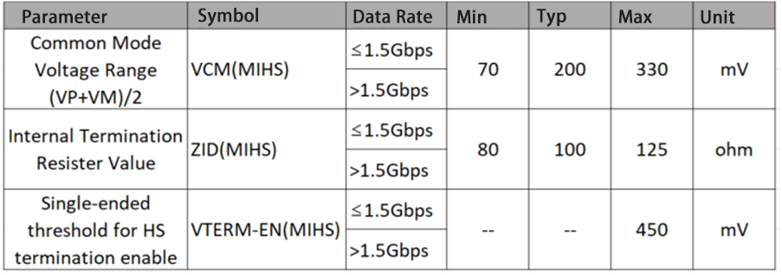

Table 2‑14 MIPI D-PHY High Speed (MIHS) Differential AC Electrical Parameters

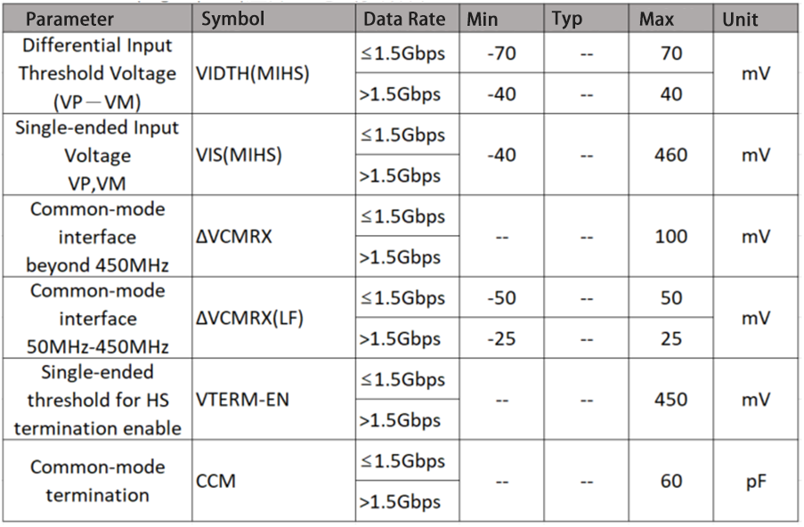

Table 2‑15 MIPI D-PHY Low Power (MILP) Differential DC Electrical Parameters

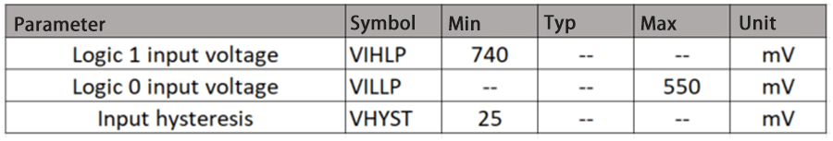

Table 2‑16 MIPI D-PHY Low Power (MILP) Differential AC Electrical Parameters

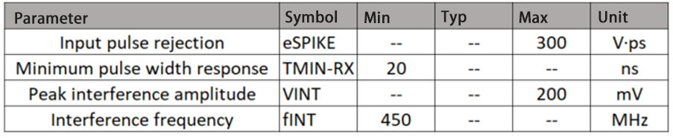

### Sub-LVDS Electrical Parameters

Electrical parameters are shown in Table 2‑17, Table 2‑18.

Table 2‑17 Sub-LVDS (SL) Differential DC Electrical Parameters

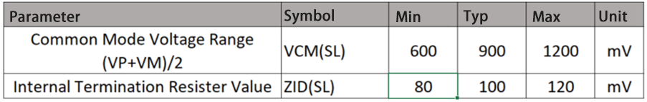

Table 2‑18 Sub-LVDS(SL) Differential AC Electrical Parameters

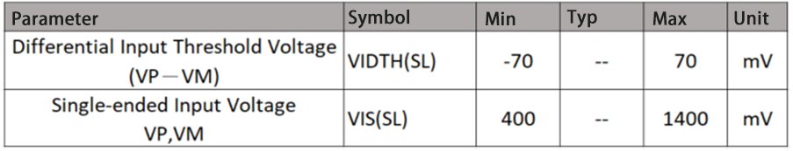

### HiSPi Electrical Parameters

HiSPi is divided into SLVS (HSSL) and HiVCM (HSHI). Their respective electrical parameters are shown in Table 2‑19 and Table 2‑20.

Table 2‑19 HiSPi Differential DC Electrical Parameters

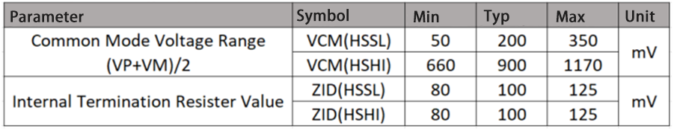

Table 2‑20 HiSPi Differential AC Electrical Parameters

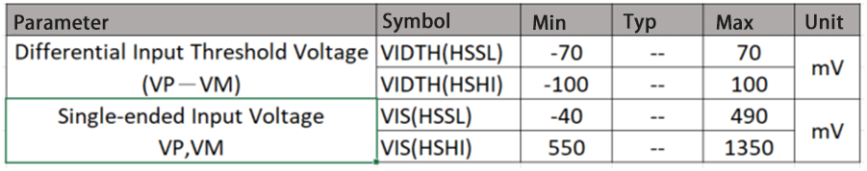

### MIPI /LVDS Tx Electrical Parameters

Table 2‑21 MIPI HS Transmitter DC Specifications

|  |  |  |  |  |  |  |
| --- | --- | --- | --- | --- | --- | --- |
| Symbol | Description | Min | Typ | Max | Units | Notes |
| VCMTX | HS transmit static common-mode voltage | 150 | 200 | 250 | mV |  |
| |ΔVCMTX(1,0)| | VCMTX mismatch when output is Differential-1 or Differential-0 | – | – | 5 | mV |  |
| |VOD| | HS transmit differential voltage | 140 | 200 | 270 | mV |  |
| |ΔVOD| | VOD mismatch when output is Differential-1 or Differential-0 | – | – | 14 | mV |  |
| VOHHS | HS output high voltage | – | – | 360 | mV |  |
| ZOS | Single ended output impedance | 40 | 50 | 62.5 | Ω |  |
| ΔZOS | Single ended output impedance mismatch | – | – | 20 | % |  |

Table 2‑22 MIPI HS Transmitter AC Specifications

|  |  |  |  |  |  |  |
| --- | --- | --- | --- | --- | --- | --- |
| Parameter | Description | Min | Typ | Max | Units | Notes |
| ΔVCMTX(HF) | Common-level variations above 450MHz | – | – | 15 | mVRMS |  |
| ΔVCMTX(LF) | Common-level variation between 50-450MHz | – | – | 25 | mVPEAK |  |
| tR and tF | 20%-80% rise time and fall time | – | – | 0.3 | UI | 1, 2 |
|  |  | – | – | 0.35 | UI | 1, 3 |
|  |  | 100 | – | – | ps | 4 |

***Note:***

*1. UI is unit interval. Example: 1UI = 1ns for 1Gbps speed.*

*2. Applicable when supporting maximum HS bit rates ≤ 1 Gbps (UI ≥ 1 ns).*

*3. Applicable when supporting maximum HS bit rates > 1 Gbps (UI ≤ 1 ns) but ≤ 1.5 Gbps (UI ≥ 0.667 ns).*

*4. Applicable when supporting maximum HS bit rates ≤ 1.5 Gbps. However, to avoid excessive radiation, bit rates < 1 Gbps (UI ≥ 1 ns), should not use values below 150 ps.*

Table 2‑23 MIPI LP Transmitter DC Specifications

|  |  |  |  |  |  |  |
| --- | --- | --- | --- | --- | --- | --- |
| Parameter | Description | Min | Typ | Max | Units | Notes |
| VOH | Thevenin output high level | 1.1 | 1.2 | 1.3 | V | 1 |
|  |  | 0.95 | – | 1.3 | V | 2 |
| VOL | Thevenin output low level | -50 | – | 50 | mV | – |
| ZOLP | Output impedance of LP transmitter | 110 | – | – | Ω |  |

***Note:***

*1. Applicable in normal Low Power mode when the supported data rate ≤1.5 Gbps.*

*2. Applicable in normal Low Power mode when the supported data rate > 1.5 Gbps.*

Table 2‑24 MIPI LP Transmitter AC Specifications

|  |  |  |  |  |  |  |
| --- | --- | --- | --- | --- | --- | --- |
| Parameter | Description | Min | Typ | Max | Units | Notes |
| TRLP/TFLP | 15%-85% rise time and fall time | – | – | 25 | ns |  |
| TREOT | 30%-85% rise time and fall time | – | – | 35 | ns |  |
| TLP-PULSE-TX | Minimum pulse width | 20 | – | – | ns |  |
| δV/δtSR | Slew rate @ CLOAD = 0 to 70pF (Falling Edge Only) | 30 | – | 300 | mV/ns | 1 |
|  |  | 25 | – | 300 | mV/ns | 2 |
| CLOAD | Load capacitance | 0 | – | 70 | pF |  |

***Note:***

*1. Applicable in normal Low Power mode when the supported data rate ≤1.5 Gbps.*

*2. Applicable in normal Low Power mode when the supported data rate > 1.5 Gbps.*

Table 2‑25 LVDS Transmitter DC/AC Specifications

|  |  |  |  |  |  |  |
| --- | --- | --- | --- | --- | --- | --- |
| Symbol | Description | Min | Typ | Max | Units | Notes |
| VOS | LVDS common mode offset voltage | 1.125 | 1.25 | 1.375 | V |  |
| |ΔVOS(1,0)| | VOS mismatch when output is Differential-1 or Differential-0 | – |  |  | mV |  |
| VOD | LVDS transmit differential voltage | 247 | 350 | 454 | mV |  |
| |ΔVOD| | VOD mismatch when output is Differential-1 or Differential-0 | – | – | 50 | mV |  |
| TRLP/TFLP | 15%-85% rise time and fall time (DUT side) |  | – | 0.3UI | ns |  |

### SDIO Electrical Parameters

EMMC / SD0 / SD1 please refer to 2.5.7 and 2.5.8

### VI RAW/BT.601/BT.656/BT.1120 Electrical Parameters

Please refer to 2.5.7 and 2.5.8 according to the domain where the IO is located.

PS. If you mix two different IOs (for example 18OD33 in 1.8V mode and 1.8V GPIO) Electrical parameters will be different. However, after simulation, the difference is small . It can meet the needs of general applications.

### VO BT.601/BT.656/BT.1120/8080 Electrical Parameters

Please refer to 2.5.7 and 2.5.8 according to the domain where the IO is located.

PS. If you mix two different IOs (for example 18OD33 in 1.8V mode and 1.8V GPIO) Electrical parameters will be different. However, after simulation, the difference is small . It can meet the needs of general applications.

### AUDIO CODEC Electrical Parameters

Table 2‑26 Audio CODEC Overall Indicator Table

|  |  |  |  |  |  |
| --- | --- | --- | --- | --- | --- |
| Parameters | Min | Typ | Max | Unit | Description |
| Analog circuit power supply AVDD | 1.62 | 1.8 | 1.98 | V |  |
| VREF |  | 1.4/1.8  *VDD |  | V |  |

Table 2‑27 Audio DAC Electrical Parameters

|  |  |  |  |  |  |  |  |  |  |  |  |
| --- | --- | --- | --- | --- | --- | --- | --- | --- | --- | --- | --- |
| Parameters | Min | | Typ | | Max | | Unit | | Description | | |
| Full output amplitude | |  | | 1.55 | |  | | Vpp | | Maximum output signal swing |

Table 2‑28 Audio ADC Electrical Parameters

|  |  |  |  |  |  |  |  |  |  |  |  |
| --- | --- | --- | --- | --- | --- | --- | --- | --- | --- | --- | --- |
| Parameters | Min | | Typ | | Max | | Unit | | Description | | |
| Maximum input amplitude | |  | | 1.75 | |  | | Vpp | | Maximum input signal swing |

## Timing

### SPI NOR Timing



Figure 2‑7 SPI NOR Timing Diagram

*IO input timing / IO output timing refers to the IO timing for SPI_NOR CMD/DATA transmission under 1xI/O, 2xI/O, 4xI/O, which includes SPINOR_SDI, SPINOR_SDO, SPINOR_HOLD_X, SPINOR_WP_X.

Table 2‑29 SPI_NOR Timing Parameter Table

|  |  |  |  |  |  |
| --- | --- | --- | --- | --- | --- |
| Symbol | Description | Min | Typ | Max | Unit |
| Tcss | Time of CS negative edge to the first clock edge | 13.4 | - | - | ns |
| Tclk | Clock Cycle | 13.4 | - | - | ns |
| Tsu | Input Signal Setup Time Requirements | 3.5 | - | - | ns |
| Thd ​ | Input Signal Hold Time Requirements | 0 | - | - | ns |
| Tov | Output Signal Delay | - | - | 2.6 | ns |
| TOX | Output Signal Holding Time | -1.5 | - | - | ns |

### SPI NAND Timing

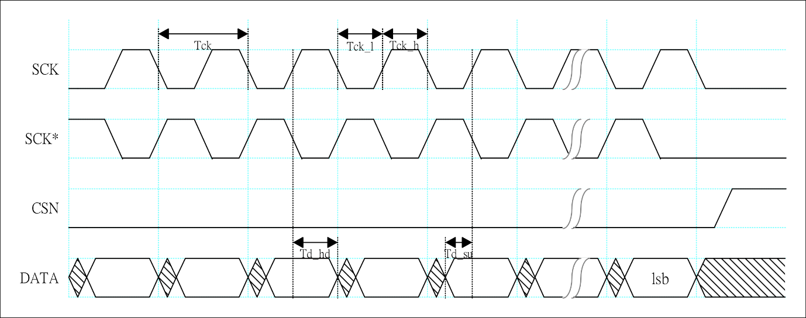

Figure 2‑8 SPI NAND Input Timing Diagram

Table 2‑30 SPI NAND Input Timing

|  |  |  |  |  |  |  |
| --- | --- | --- | --- | --- | --- | --- |
| Parameters | Symbol | Min | Typ | Max | Unit | |
| Clock Cycle | Tck | 10.66 |  | 170.56 | ns |
| Input Signal Setup Time Requirements | Td_su | 2.00 |  |  | ns |
| Input Signal Hold Time Requirements | Td_hd | 1.20 |  |  | ns |

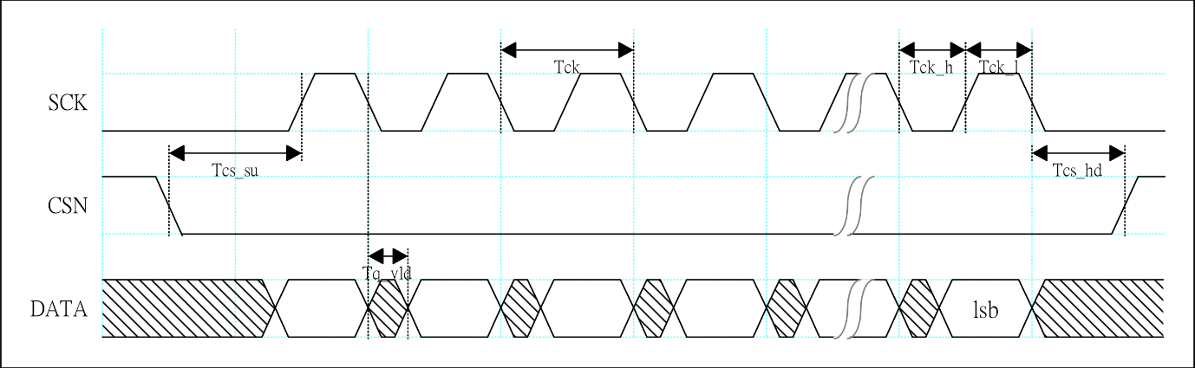

Figure 2‑9 SPI NAND Output Timing Diagram

Table 2‑31 SPI NAND Output Timing

|  |  |  |  |  |  |  |
| --- | --- | --- | --- | --- | --- | --- |
| Parameters | Symbol | Min | Typ | Max | Unit | |
| Clock Cycle | Tck | 10.66 |  | 170.56 | ns |
| Clock High Period | Tck_h | 5.33 |  | 85.28 | ns |
| Clock Low Period | Tck_l | 5.33 |  | 85.28 | ns |
| Output CS Setup Time | Tcs_su | 10.66 |  |  | ns |
| Output CS Hold Time | Tcs_hd | 10.66 |  |  | ns |
| Output Signal Delay | Tq_vld | -1.00 |  | 2.00 | ns |

### VI Timing

VI timing sequence is shown in Figure 2‑10.



Figure 2‑10 VI Timing Diagram

The VI timing parameters are shown in Table 2‑32.

Table 2‑32 VI Timing Parameter Table

|  |  |  |  |  |  |
| --- | --- | --- | --- | --- | --- |
|  | Symbol | Min | Typ | Max | Unit |
| VICLK clock cycle | T | 6.73 |  |  | ns |
| VIDATA setup time | Tsu | 1.9 |  |  | ns |
| VIDATA hold time | Thd | 0.8 |  |  | ns |

### VO Timing

VO interface is shown in Figure 2‑11.



Figure 2‑11 VO Timing Diagram

The VO timing parameters are shown in Table 2‑33.

Table 2‑33 VO Timing Parameter Table

|  |  |  |  |  |  |
| --- | --- | --- | --- | --- | --- |
|  | Symbol | Min | Typ | Max | Unit |
| VOCLK clock cycle | T |  | 6.73 |  | ns |
| VODATA delay time | Tov | T/2-1.5 |  | T/2+1.5 | ns |

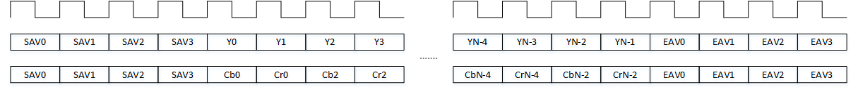

Figure 2‑12 BT.656 Timing Diagram

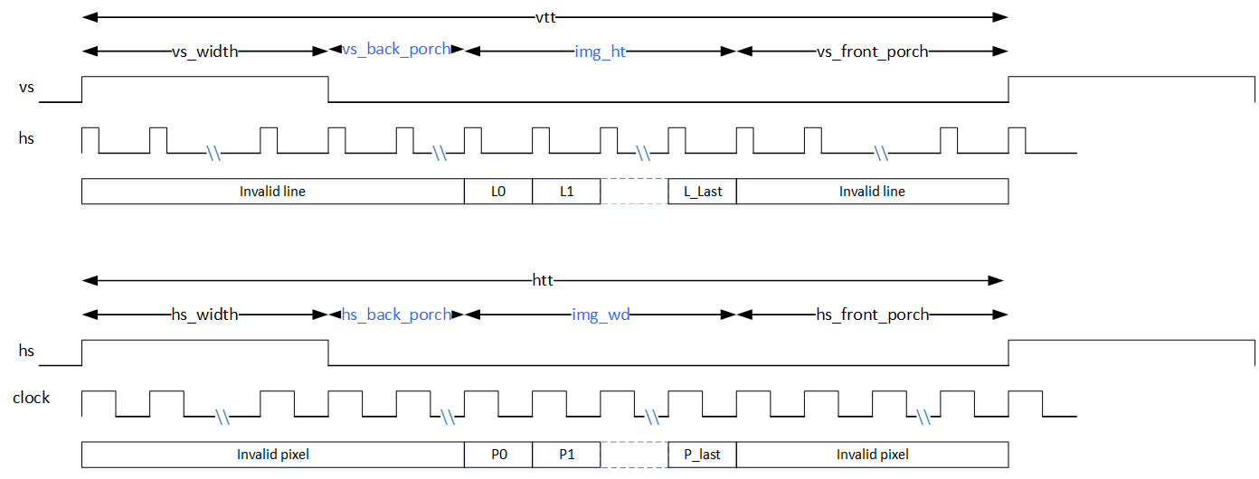

Figure 2‑13 BT.601 Timing Diagram



Figure 2‑14 BT.1120 Timing Diagram

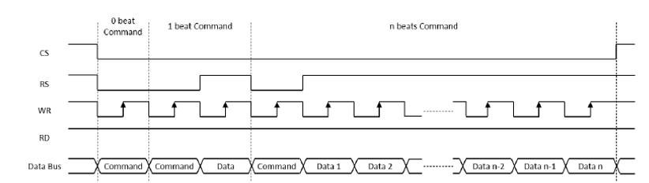

Figure 2‑15 8080 Timing Diagram

### AIAO (I2S/PCM) Timing

The RX timing diagram of I2S and PCM modes for connecting with external Audio Codec is shown in Figure 2‑16.

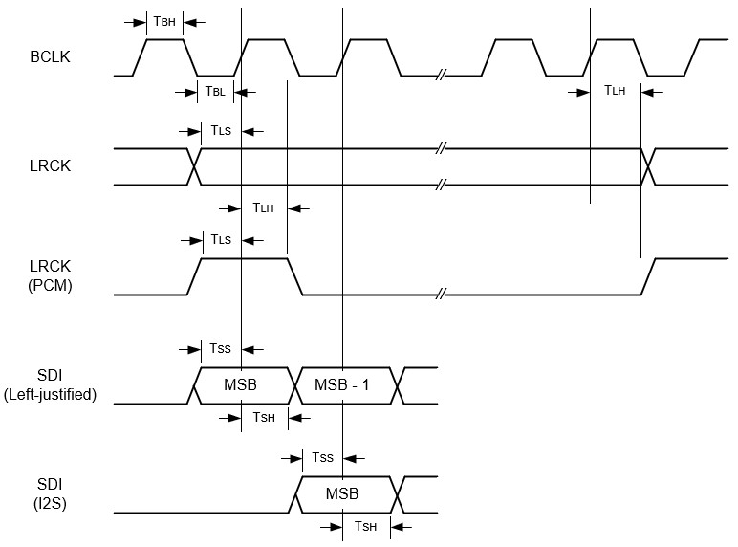

Figure 2‑16 I2S & PCM Rx Timing Diagram

The Tx timing diagram of I2S and PCM modes is shown in Figure 2‑17.

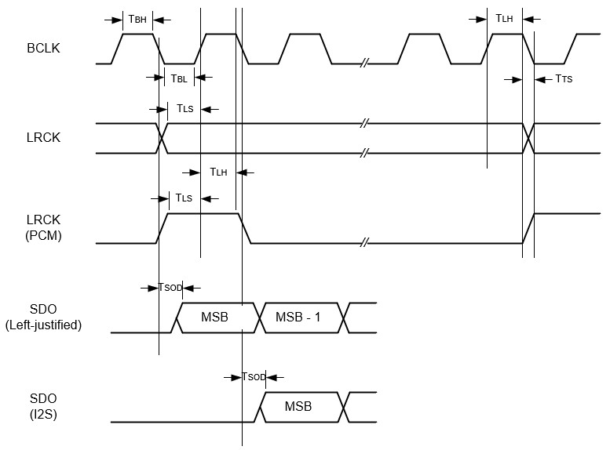

Figure 2‑17 I2S & PCM Tx Timing Diagram

The timing parameters are shown in Table 2‑34.

Table 2‑34 I2S/PCM Timing Parameter Table

|  |  |  |  |  |  |  |
| --- | --- | --- | --- | --- | --- | --- |
| Symbol | Parameter | Min | Typ | Max | Unit | |
| TBL | BCLK low level pulse width (master mode and slave mode) | 40 | - | - | ns |
| TBH | BCLK high level pulse width (master mode and slave mode) | 40 | - | - | ns |
| TLS | LRCK settling time relative to BCLK rising edge (slave mode) | 10 | - | - | ns |
| TLH | LRCK hold time relative to BCLK rising edge (slave mode) | 10 | - | - | ns |
| TSS | SDI settling time relative to BCLK rising edge (master mode and slave mode) | 10 | - | - | ns |
| TSH | SDI hold time relative to BCLK rising edge (master mode and slave mode) | 10 | - | - | ns |
| TTS | BCLK falling edge clock skew relative to LRCK (master mode) | 0 | - | 10 | ns |
| TSOD | SDO signal delay time relative to BCLK falling edge (master mode and slave mode) | 0 | - | 10 | ns |

### I2C Timing

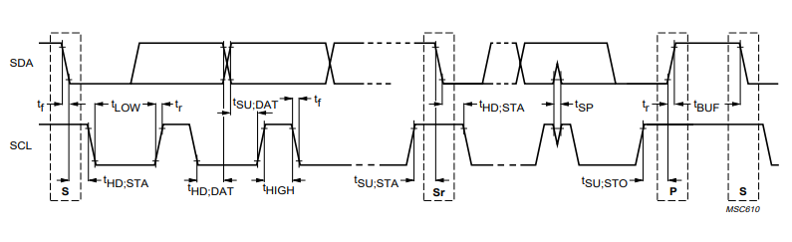

Figure 2‑18 I2C Timing Diagram

Table 2‑35 I2C Timing Parameter Table

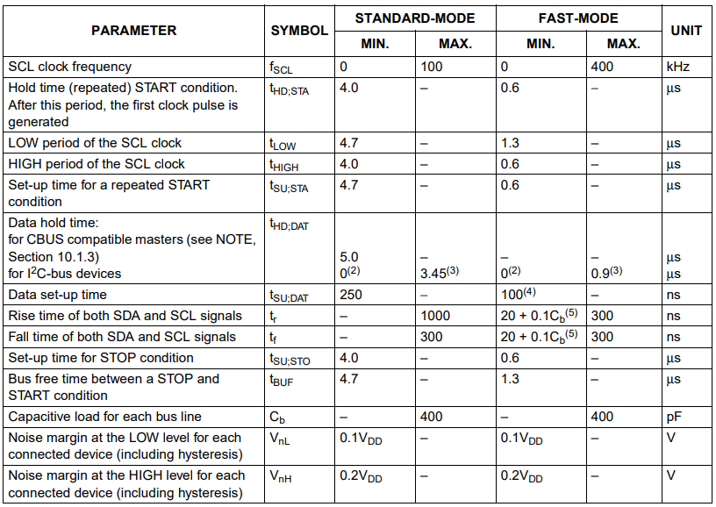

### SPI Timing



Figure 2‑19 SPI Timing Diagram

Table 2‑36 SPI Timing Parameter Table

|  |  |  |  |  |  |
| --- | --- | --- | --- | --- | --- |
| Symbol | Description | Min | Typ | Max | Unit |
| Fclk | SCK Frequency |  | - | 46.8 | MHz |
| Tcss | Time of CS negative edge to the first clock edge | 21.4 | - | - | ns |
| Tclk | clock cycle | 21.4 | - | - | ns |
| Tsu | Input signal setup time requirements | 9.5 | - | - | ns |
| Thd | Input signal hold time requirements | 0 | - | - | ns |
| Tov | Output signal effective delay | - | - | 3 | ns |
| TOX | Output signal holding time | -3 | - | - | ns |

### MIPI Rx Timing

The speed range of MIPI Rx is: 0.08Gbps ≤ data rate ≤ 1.5Gbps

**A.0.08Gbps ≤ data rate ≤ 1.5Gbps**

The timing diagram is shown in Figure 2‑20 and the timing parameters are shown in Table 2‑37.



Figure 2‑20 Timing Diagram of MIPI Rx Clock when 0.08Gbps ≤ Data Rate ≤ 1.5Gbps

Table 2‑37 Timing Parameter of MIPI Rx at 0.08Gbps ≤ Data Rate ≤ 1.5Gbps

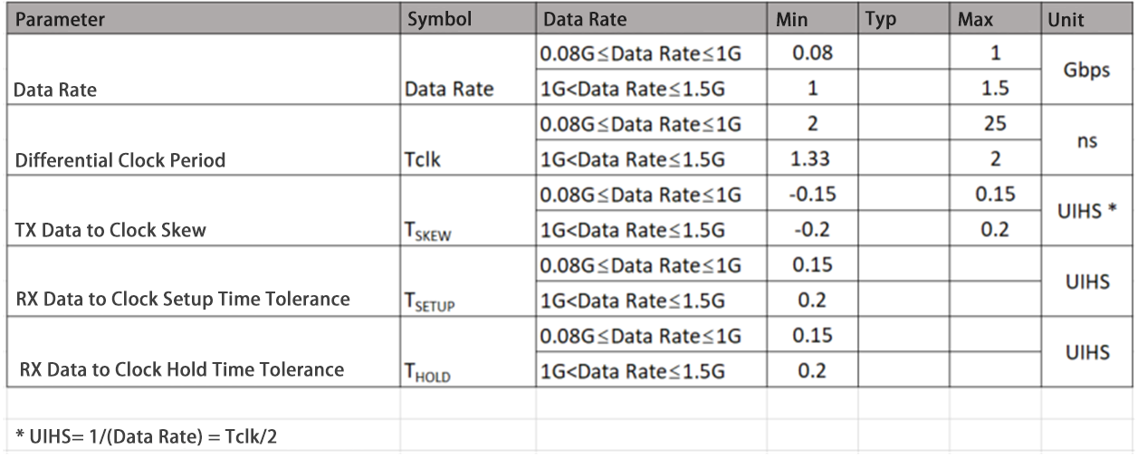

### Sub-LVDS Timing

The Sub-LVDS clock data timing diagram is shown in Figure 2‑21 and the timing parameters are shown in Table 2‑38.



Figure 2‑21 Sub-LVDSClock Data Timing Diagram

Table 2‑38 Sub-LVDS Timing Parameter Table

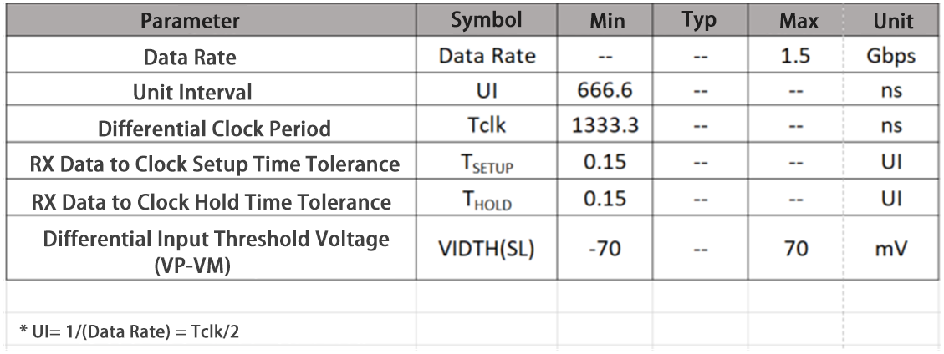

### HiSPi Timing

The HiSPi clock data timing diagram is shown in Figure 2‑22 and the timing parameters are shown in Table 2‑39.



Figure 2‑22 HiSPi Clock Data Timing Diagram

Table 2‑39 HiSPi Timing Parameters Table

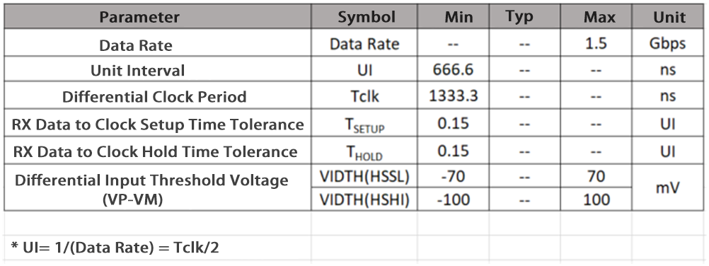

### MIPI Tx Timing

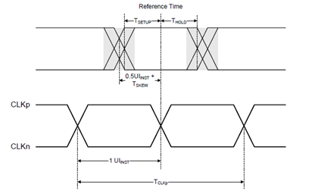

Figure 2‑23 MIPI TX Data-to-Clock Timing Diagram

Table 2‑40 Data-Clock Timing Specifications for ≥ 0.08Gbps and ≤ 1 Gbps

|  |  |  |  |  |  |  |
| --- | --- | --- | --- | --- | --- | --- |
| Symbol | Description | Min | Nom | Max | Units | Notes |
| TSKEW[TX] | TX Data to Clock Skew | -0.15 |  | 0.15 | UIHS |  |

Table 2‑41 Data-Clock Timing Specifications for > 1Gbps and ≤ 1.5 Gbps

|  |  |  |  |  |  |  |  |
| --- | --- | --- | --- | --- | --- | --- | --- |
| Symbol | Description | Min | Nom | Max | Units | Notes | |
| TSKEW[TX] | TX Data to Clock Skew | -0.2 |  | 0.2 | UIHS |  |

Table 2‑42 Data-Clock Timing Specifications for > 1.5Gbps and ≤ 2.5 Gbps

|  |  |  |  |  |  |  |
| --- | --- | --- | --- | --- | --- | --- |
| Symbol | Description | Min | Nom | Max | Units | Notes |
| TSKEW[TX] | TX Data to Clock Skew | -0.2 |  | 0.2 | UIHS |  |
| TJTX | TX Data to Clock Total Jitter |  |  | 0.3 | UIHS |  |
| DJTX | TX Data to Clock Deterministic Jitter |  |  | 0.2 | UIHS |  |
| RJTX | TX Data to Clock Random Jitter |  |  | 0.1 | UIHS |  |

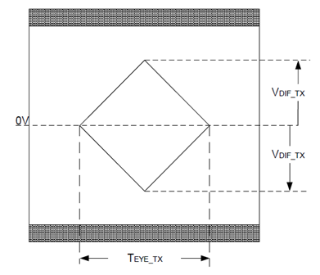

Figure 2‑24 TX EYE Diagram Specification

Table 2‑43 Transmitter Eye Diagram Specification

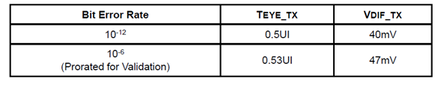

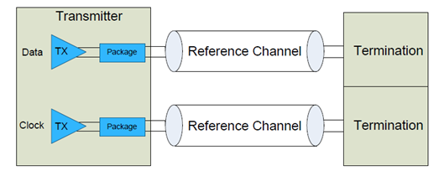

Figure 2‑25 Transmitter Eye Diagram Validation Setup

### SDIO/MMC Timing

The data input/output timing for a single edge is shown in Figure 2‑26.



Figure 2‑26 SDIO/MMC single-edge (SDR) data input/output timing diagram

Table 2‑44 SDIO/MMC Single Edge DS (default speed) Mode Timing Parameter Table

|  |  |  |  |  |  |  |
| --- | --- | --- | --- | --- | --- | --- |
| Parameters | Symbol | Min | Typ | Max | Unit | Note |
| Clock CLK | | | | | | |
| Clock frequency Data transfer Mode | fPP | 0 | - | 26 | MHz | fpp=1/tpp  CL≤30pF |
| Clock frequency Identification Mode | fOD | 0 | - | 400 | KHz | CL≤30pF |
| Clock high time | tWH | 10 | - | - | ns | CL≤30pF |
| Clock low time | tWL | 10 | - | - | ns | CL≤30pF |
| Clock rise time | tTLH | - | - | 10 | ns | CL≤30pF |
| Clock fall time | tTHL | - | - | 10 | ns | CL≤30pF |
| Inputs CMD, DAT (referenced to CLK) | | | | | | |
| Input set-up time | tISU | 6 | - | - | ns | CL≤30pF |
| Input hold time | tIH | 8.3 | - | - | ns | CL≤30pF |
| Outputs CMD, DAT (referenced to CLK) | | | | | | |
| Output set-up time | tOSU | 5 | - | - | ns | CL≤30pF |
| Output hold time | tOH | 5 | - | - | ns | CL≤30pF |

Table 2‑45 SDIO/MMC Single Edge HS (High speed) Mode Timing Parameter Table

|  |  |  |  |  |  |  |
| --- | --- | --- | --- | --- | --- | --- |
| Parameters | Symbol | Min | Typ | Max | Unit | Note |
| Clock CLK | | | | | | |
| Clock frequency Data transfer Mode | fpp | 0 | - | 52 | MHz | fpp=1/tpp  CL≤30pF |
| Clock high time | tWH | 6.5 | - | - | ns | CL≤30pF |
| Clock low time | tWL | 6.5 | - | - | ns | CL≤30pF |
| Clock rise time | tTLH | - | - | 3 | ns | CL≤30pF |
| Clock fall time | tTHL | - | - | 3 | ns | CL≤30pF |
| Inputs CMD, DAT (referenced to CLK) | | | | | | |
| Input set-up time | tISU | 6 | - | - | ns | CL≤30pF |
| Input hold time | tIH | 2.5 | - | - | ns | CL≤30pF |
| Outputs CMD, DAT (referenced to CLK) | | | | | | |
| Output set-up time | tOSU | 6 | - | - | ns | CL≤30pF |
| Output hold time | tOH | 3 | - | - | ns | CL≤30pF |

The timing of double edge data input/output is shown in Figure 2‑27.



Figure 2‑27 SDIO/MMC double edge DDR50 mode data input/output timing diagram

Table 2‑46 SDIO/MMC Double Edge DDR50 Mode Timing Parameter Table

|  |  |  |  |  |  |  |
| --- | --- | --- | --- | --- | --- | --- |
| Parameters | Symbol | Min | Typ | Max | Unit | Note |
| Clock CLK | | | | | | |
| Clock frequency Data transfer Mode | fP | 0 | - | 52 | MHz | fpp=1/tpp  CL≤30pF |
| Inputs DAT (referenced to CLK) | | | | | | |
| Input delay time during data transfer | tIDLYddr | 1.5 | - | 7 | ns | CL≤20pF |
| Outputs DAT (referenced to CLK) | | | | | | |
| Output set-up time | tOSU | 3 | - | - | ns | CL≤20pF |
| Output hold time | tOH | 2.5 | - | - | ns | CL≤20pF |

The timing diagram of HS200 and SDR104 data input/output is shown in Figure 2‑28.



Figure 2‑28 SDIO/MMC HS200 and SDR104 mode data command input/output timing diagram

Table 2‑47 SDIO/MMC HS200 and SDR104 Mode Output Parameters Table

|  |  |  |  |  |  |  |
| --- | --- | --- | --- | --- | --- | --- |
| Parameters | Symbol | Min | Typ | Max | Unit | Note |
| Output set-up time | tOSU | 1.4 | - | - | ns | CDEVICE≤6pF |
| Output hold time | tOH | 0.8 | - | - | ns |  |

Table 2‑48 SDIO/MMC HS200 and SDR104 Mode Input Timing Parameter Table

|  |  |  |  |  |  |  |
| --- | --- | --- | --- | --- | --- | --- |
| Parameters | Symbol | Min | Typ | Max | Unit | Note |
| Phase difference between device TX CMD/DAT and RX CLK | tPH | 0 | - | 2 | UI | Unit Interval (UI) is one-bit nominal time. For 200Mhz, UI=5ns |
| Input valid data window | tVW | 0.575 | - | - | UI | TVW=2.88ns at 200MHz |